Thresher on the Move
Young innovator reduces harvest losses, boosts food security

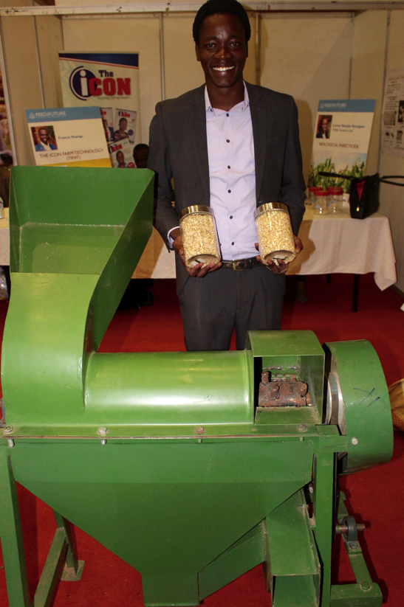
About the size of a wheelbarrow, Stephen Ssekanyo’s “Kungula thresher” fits nicely on the back of a motorcycle. That means he can deliver it deep into rural areas where the unpaved roads become tracks and farmers rarely gain access to technologies. But by delivering his innovation to the farmer’s fields he is helping them get clean, ready-to-package maize at a price they can afford.

Common postharvest practices among rural farmers in Africa lead to 60 percent food loss. Smaller-holder farmers in East Africa typically spend hours laboriously hand shelling or “stick beating” – the practice of repeatedly whacking a bag of maize cobs with a stick to remove the kernels.

Stephen’s tool is reducing postharvest losses. Unlike many models of mechanized threshers, the “Kungula thresher” can handle cobs that have a high-moisture level, catering to the realities of smallholder farmers who do not have adequate cob storage, and cannot wait for sale or consumption.

The machine can thresh and winnow 1,000 kg of maize in one hour, using only a liter of fuel. The clean kernels fetch a higher price from millers and attract less moisture in storage.

Finding solutions to complex development challenges is paramount to why the U.S. Government’s Feed the Future Initiative supported a competition in East Africa for locally driven solutions for greater food security.
About the size of a wheelbarrow, Stephen Ssekanyo’s “Kungula thresher” fits nicely within his 3- by 2-meter exhibitor’s booth at the East African Farmers Federation Congress.

Stephen was a finalist in USAID’s East Africa Postharvest Technology Competition and training program, from February to May 2017. He field-tested his thresher in two districts of central Uganda for an entire year before the competition. He calculated that he reached 624 farmers with just six machines.

He has since sold nearly 50 threshers at a $1,000 each. Farmers buy the thresher as a group and transport it from farm-to-farm, significantly reducing the labor time and cost for all involved.

Like any good entrepreneur, Stephen has been continually adjusting the machine based on farmer feedback. “We haven’t received any complaints about the machine in six months,” he said. I think we’ve made all the adjustments needed.”

Another USAID project, the Resilient Africa Network, helped Stephen and his team design the original “Kungula thresher.”

Stephen’s thresher and success in early sales is exactly what the Feed the Future Initiative, through USAID, wanted as an outcome of the competition – a cadre of young innovators galvanized to find solutions to Africa’s greatest challenges with the motivation and skills to scale up their innovations for regional uptake.

The adoption of these technologies across East Africa will help reduce post-harvest loss in the region and consequently increase trade in agricultural commodities.

This competition is the perfect example of how Feed the Future works together with its partners across the East Africa region to build a world free from hunger, poverty and undernutrition.

