Small changes make a big difference in Madagascar
Written by Bruno Rasamoel

“I’m now able to buy new clothes for me and my family, and my neighbors are now more considerate and respectful. Our life has changed thanks to the center and USAID’s support.”
_____________________________________________________________________________________

On a hill amidst unkempt grass and wild vegetation on the outskirts of Madagascar’s capital, Antananarivo, stands a shabby-looking wooden hut, surrounded by banana trees and other makeshift shelters. A few feet below, a middle-aged woman is attending to a few customers that come to buy items at her food stand. Her name is Honorine, and the hut is her home. Her life has substantially improved thanks to a USAID-funded food security program.

ASA or Ankohonana Sahirana Arenina (promotion of vulnerable families) is one of five social protection centers partnering with Catholic Relief Services (CRS) in Antananarivo to provide technical assistance and training, as well as food rations, to poor families in this teeming city. Annually, the center identifies about 40 extremely vulnerable households –mostly headed by women—and provides them with training in income-generating activities that will help them earn a decent living. Household members come to the center for a 10-month training, and receive a monthly food ration of corn-soy blend, fortified cooking oil, and rice. On completion of their training, they are given equipment to help start up the business of their choice.

Julienne is one beneficiary of the project, who received training and equipment from the center. She started pig farming in 2010, and she has since increased her livestock by 300 percent. Using sales proceeds, she has embarked on brickmaking and is now building a house for her family.

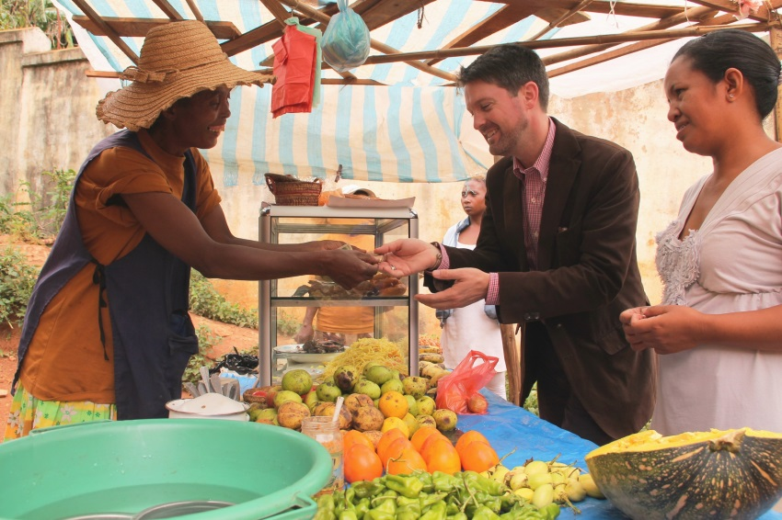
Germaine used to do laundry for a living, which would barely help her make ends meet. Joining the center helped her save some money, which she used to buy a sewing machine and start a sewing business. She then diversified into chicken farming and earned enough money to send her children to school. The farming is doing very well, and Germaine is now turning her mud house into a brick home.

Bodo, another beneficiary, is the widowed mother of five children. Before she entered the program, she felt ostracized because she was poor, and her neighbors and relatives would look down on her. Her life
improved soon after joining ASA as she could earn and even save money thanks to chicken farming. “I’m now able to buy new clothes for me and my family, and my neighbors are now more considerate and respectful. Our life has changed thanks to the center and USAID’s support”, she said.

With the help of the center, Honorine started a small food stand selling homemade soup, doughnuts, noodles, fruit, and other vegetables. Although she still lives in a wooden hut, her life has
Christopher La Fargue, FFP Officer, buys fruit at Honorine’s food stand
Photo: Bruno Rasamoel

nonetheless improved. With the money that she saved, she bought two pigs that are kept in the countryside, and she is confident her life will continue to improve, as she has seen with her fellow ASA peers.

Ms. Sarah, the ASA project coordinator spoke highly of the USAID funded project (“Strengthening and Accessing Livelihood Opportunities for Household Impact” - SALOHI) that helped many vulnerable families improve their living conditions. Eight hundred and forty families in Antananarivo have benefited from the project since it started in 2009, and 2,549 households among 15 social protection centers throughout the country. Although this food security program ends in June 2014, and food distribution ended last September, the ASA center will continue to provide training to the most vulnerable in the city, and Ms. Sarah seeks to expand ASA activities with support from other donors.

# # #

