



Каzakhstan is among the world's 27 high-burden countries for multidrug-resistant TB (MDR-TB). Kazakhstan’s National TB Program (NTP) has made great strides in modernizing its TB strategy since 1998, following WHO guidelines. The current TB program, based on the 2006 Stop TB Strategy, has significantly improved the TB situation in the country. However, almost one in five new TB cases are MDR-TB, and half of all returning patients who had previously been treated for TB have since contracted MDR-TB. In all, 10,575 MDR-TB patients have been registered in the country since 2012.

In 2012, TB CARE I introduced new rapid diagnostic tools, including four GeneXpert MTB/RIF machines, to Kazakhstan to diagnose MDR-TB more rapidly and facilitate more effective treatment. To build on this success, the NTP requested technical input from TB CARE I for the development of national guidelines on MDR-TB that could direct all health professionals across the country, in order to more effectively treat MDR-TB and lower the country’s burden.

A team of national clinical practitioners led by TB CARE I worked collaboratively to draft the guidelines, drawing on best practices, practical research and professional experience. The draft chapters were reviewed by external experts, and the final draft was subsequently approved by the TB Department of the Ministry of Health in early September 2014.

The successfully completed policies are now available to clinicians, researchers and medical staff nationwide, and are offering patients hope as MDR- TB can now be more effectively managed in Kazakhstan.

Specialists from NTP as well as from pilot sites discuss MDR-TB guideline

## New guidelines will help National TB program to fight TB

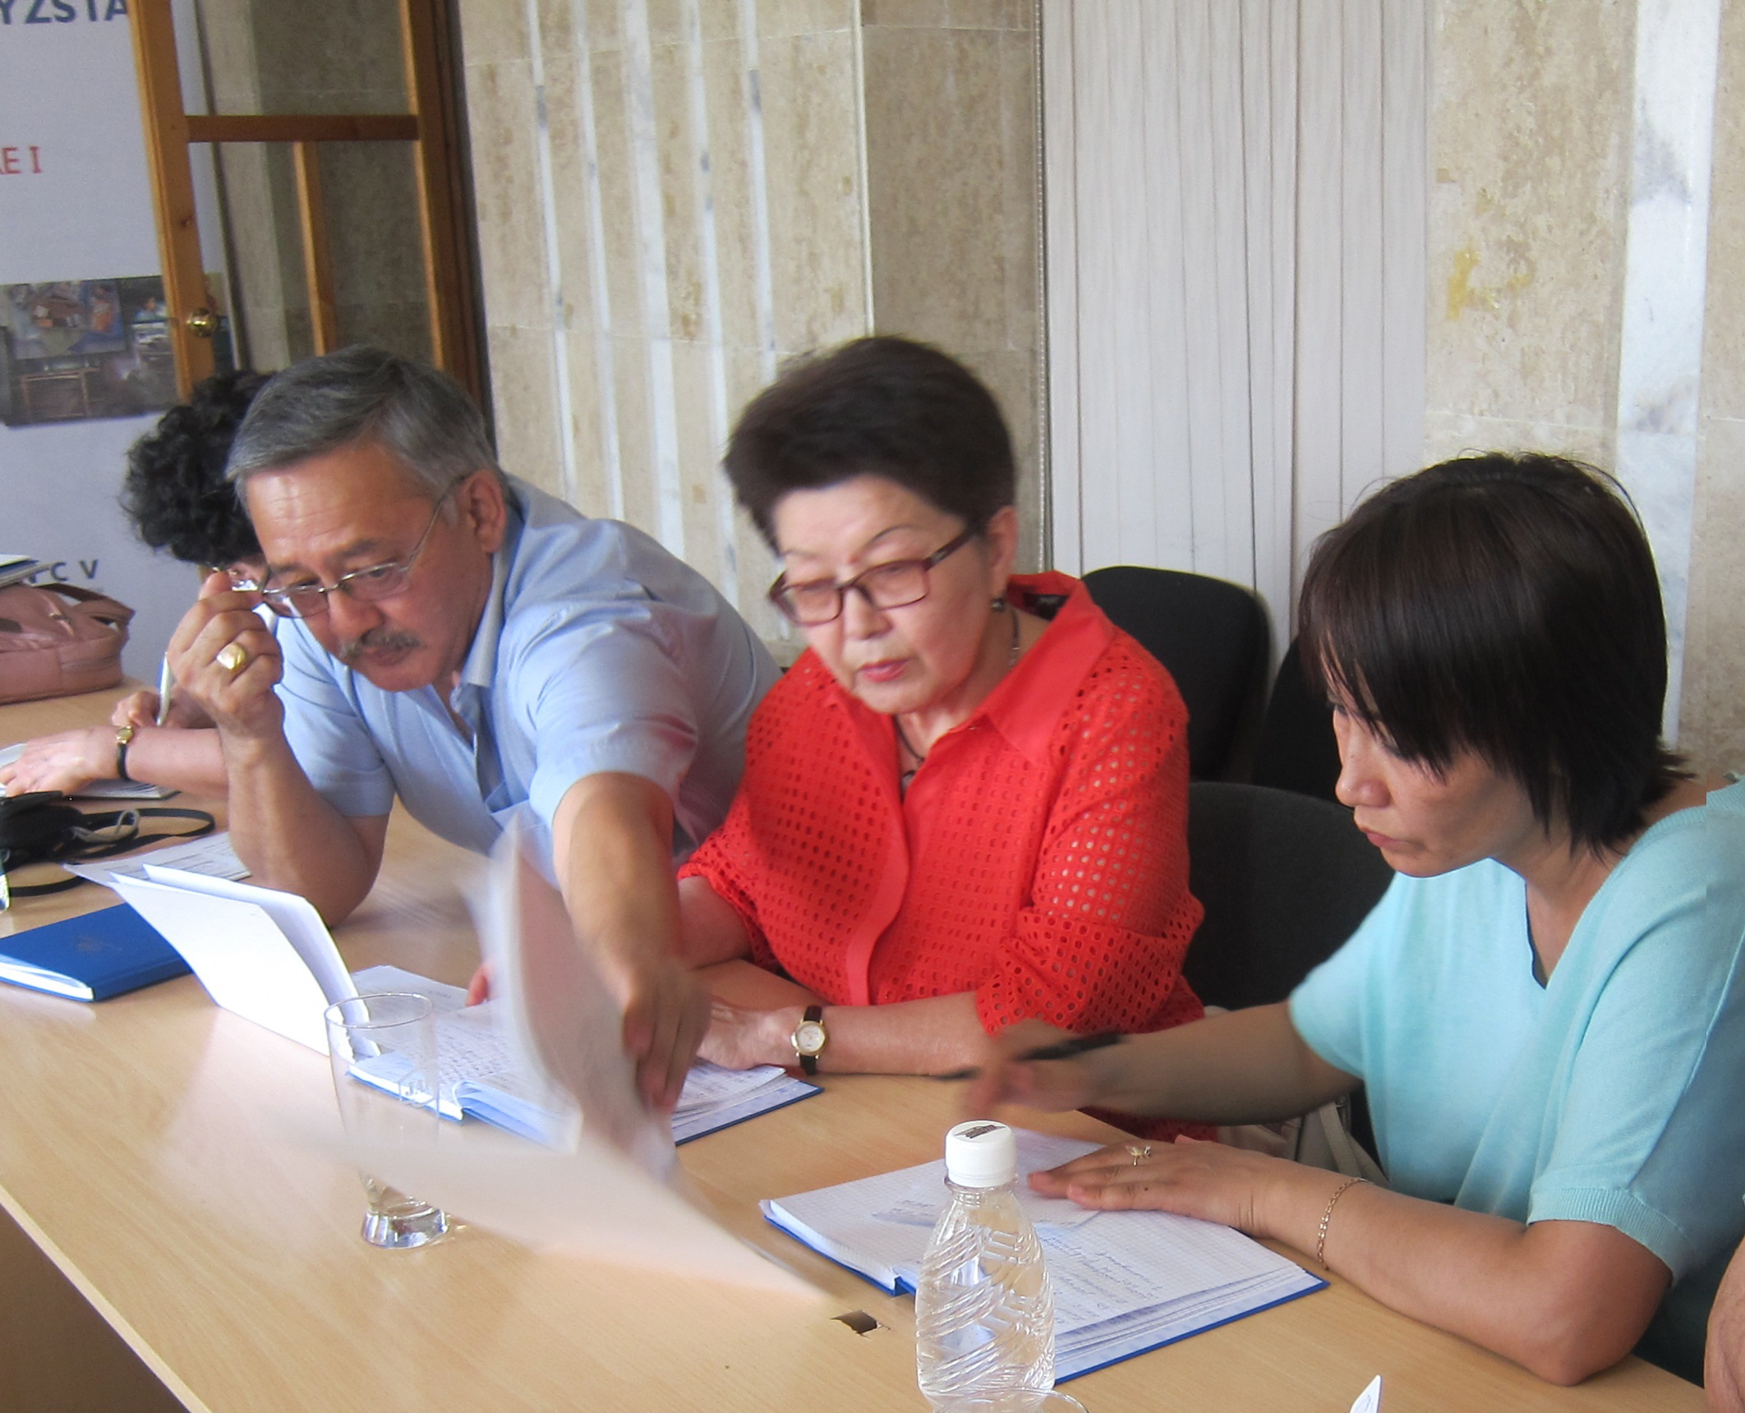

“The newly-developed MDR-TB guidelines were urgently need now to respond effectively and in a timely manner to the needs of the patients with drug resistance TB in our country.” – said Elmira Berikova, Deputy Director, National TB Center

[Insert Photo by TB CARE I

# Kazakhstan National MDR-TB Guidelines Championed by TB CARE I