Most tuberculosis (TB) patients in Kazakhstan, including non-infectious TB patients, are hospitalized from the time of their initial diagnosis to the end of the intensive phase of treatment. This ranges from two to four months for regular TB, and six to twelve months for multidrug-resistant TB (MDR-TB) cases. In addition to costing a significant portion of Kazakhstan’s national funding for TB, such lengthy hospitalizations do not comply with World Health Organization guidelines and other internationally accepted standards of care. Furthermore, they often result in negative social, psychological, and emotional effects on persons with TB and their families while exposing them to the high risk of contracting other, deadlier strains of TB. The current treatment model unnecessarily takes TB patients out of the workforce for months, which often results in detrimental economic consequences for families and communities.

The USAID-funded TB CARE I project piloted full outpatient care for TB patients in the Akmola region of Kazakhstan in May 2011. Using an approach recommended by the World Health Organization, the project introduced shorter hospitalization options, such as home-based care and services through clinics at TB hospitals, and psychosocial support. For the first time in Kazakh history, the project introduced treatment for non-infectious patients in outpatient settings. In addition to allowing patients the option to get better in the comfort of their own home, it reduced costs across the board for the TB program, families and communities. Since this pilot, USAID and TB CARE I scaled the model to regional health authorities and regional TB facilities. They also established a training center at the Akmola regional TB dispensary to provide in-service training for TB professionals that allows them to effectively implement this new outpatient approach throughout the region.

With an endorsement from Kazakhstan’s National TB Program, the model has been gradually scaled up through Akmola Oblast. The majority of TB and primary health care facilities at regional, district, and rural levels have adopted this model. The increased use of home-based care and the introduction of outpatient clinic services have worked well for persons with TB. Facilities report minimal treatment interruptions and not a single loss to follow up has been reported to date. “Due to the opportunity to be an ambulatory patient, I came back to my family, studies and friends,” says Olzhas T., a 16-year-old college student. His words are echoed by Natasha K., a young mother who contracted MDR-TB while caring for her one-year-old baby: “Receiving care at the Kokshetau outpatient clinic was vital for me because I was not separated from my child.”

With USAID’s support, 32% of MDR-TB patients in Akmola Oblast were enrolled in outpatient care in 2012, compared to only 10% in 2011. This shift has led to a reduction of 70 adult and 20 children’s beds in TB facilities in the region, with the resultant savings now funding more effective TB interventions. Provisional estimates indicate at least a three-fold decrease in the costs associated with outpatient care when compared to hospital-based care for both regular TB and MDR-TB patients.
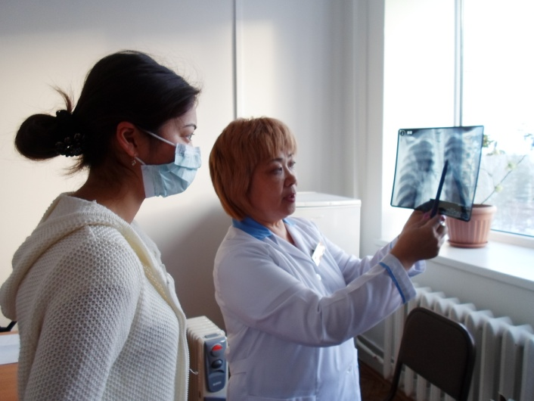
New Patient-Centered Model Successfully Expands Outpatient Tuberculosis Care in the Akmola Region

