Orange-fleshed Sweet Potatoes: Improving Lives in Uganda

A nutritious sweet potato variety is growing in popularity and becoming an important strategy to improve vitamin A deficiency across Uganda. Orange-fleshed sweet potato (OFSP) is rich in vitamin A and is being disseminated with support from USAID under Feed the Future, the U.S. Government’s global hunger and food security initiative. Introduced in 2007 by HarvestPlus, a part of the Consultative Group on International Agricultural Research (CGIAR) Program on Agriculture for Nutrition and Health, OFSP has now been adopted by over 55,000 Ugandan farming households, with up to 237,000 households expected to be planting and eating it by 2018. There are currently four varieties of this potato although during the month of November 2013, the government of Uganda released two more varieties.

USAID’s mission in Uganda is working to improve household nutrition and agricultural livelihoods through production and consumption of these bio-fortified pro-vitamin-A-rich sweet potatoes. Bio-fortification aims to reduce micronutrient deficiency through traditional breeding of certain crops that contain higher levels of essential micronutrients. Vitamin A deficiency is a significant health concern that impacts 38 percent of children 6-59 months and 36 percent of women age 15-49 years, according to the 2011Uganda Demographic and Health Survey. “Uganda was selected to pilot OFSP breeding and dissemination because sweet potato is grown by over 44 percent of Ugandan farmers and is the fourth most important staple food in the country,” explained Anna-Marie Ball, HarvestPlus Country Manager for Uganda.

Vitamin A deficiency impedes children’s growth, increases their vulnerability to disease, and contributes to poor immune function and maternal mortality. Recent figures released by the International Potato Center indicate that OFSP is an important source of beta-carotene, the pre-cursor to vitamin A. Just 125 grams of a fresh sweet potato root from most orange-fleshed varieties contains enough beta-carotene to provide the daily pro-vitamin A needs of a preschooler. Vitamin A deficiency is rampant in Sub-Saharan Africa, affecting 43 million children under age 5, and contributing to high rates of blindness, disease, and premature death in children and pregnant women.

Charles Musoke, a Seed Systems Specialist working with HarvestPlus Uganda, explained that the orange-fleshed sweet potato is cross-bred with local potato varieties. In addition to addressing vitamin A deficiencies, it is as sweet as the indigenous white sweet potato, and has high and fast-maturing yields.

Agricultural extension staff works closely with farmers’ groups and other stakeholders to ensure widespread OFSP availability and sustainability. Dr. Ball believes that if enough people receive the vines, plant them, and take good care of them, the bio-fortified OFSP variety can become well-established across Uganda. Schools around Uganda where potatoes constitute the main crop grown in school gardens showed interest in OFSP. “In Kole district, students of Aboke Girls’ Primary School are focusing on orange-fleshed sweet potatoes with the aim of multiplying the vines. The aim is to multiply them so that each student can have sufficient quantities to take home for their parents to plant extensively,” stated Odong Stephen, a field extension worker with World Vision Uganda. Kyalisiima Kate, a Project Coordinator with Caritas Development Organization, explains that people are interested in growing OFSP mainly for home consumption. “In Kibaale district, 53 pupils of Buruku Primary School and 18 from Rwentale Primary School actively took part in the planting of OFSP in their respective gardens. While the teachers ate the roots, the pupils carried the vines for their parents to plant at home,” she added.

HarvestPlus provides information and training to farmers on how to conserve the potato vines from season to season. Nutrition training is also offered to the farmers. Families learn how to prepare the potatoes as a component of a balanced diet. OFSP also contributes to the nutritional needs of young children, and pregnant and breastfeeding women. “Our beneficiaries are sensitized about the range of food preparation approaches. Besides steaming and boiling, families make flour from the orange potatoes, which, in combination with wheat flour and other ingredients, can be used to make chapatti, donuts, and porridge.” said Dr. Ball.

With support from USAID; HarvestPlus is proactively working to link OFSP farmers to markets. Through personal connections, traders are educated about the nutritional benefits of OFSP and rapport is being built between the OFSP farmers and traders. HarvestPlus is also working with larger, commercial farmer groups (those who plant the OFSP on more than one acre of land) around Kampala, Mbarara, Mbale and Gulu districts and relies on their already-established hubs for marketing. This ensures that OFSP gets to the market so that everyone can access them.

OFSP holds much promise for both farmers and families as its popularity grows in Uganda.

Photos:
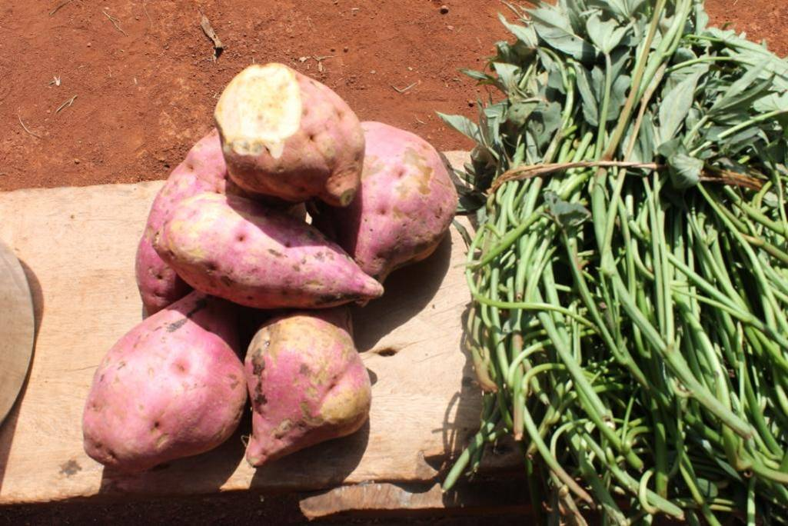
A heap of freshly harvested orange-fleshed sweet potatoes (l) and to the right is a pile of fresh, ready-to-plant vines.

Photo Credits: USAID/Uganda

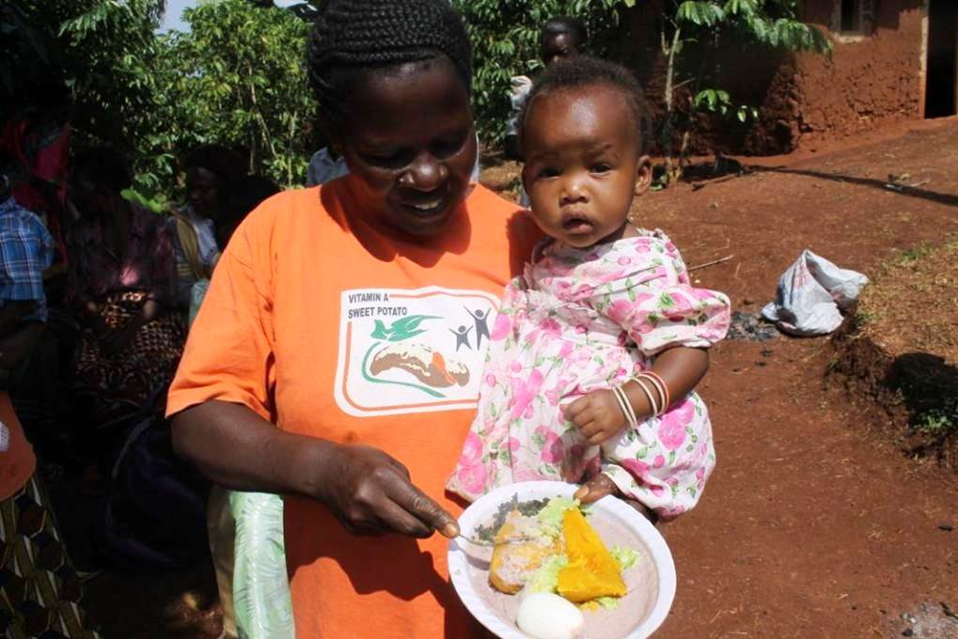
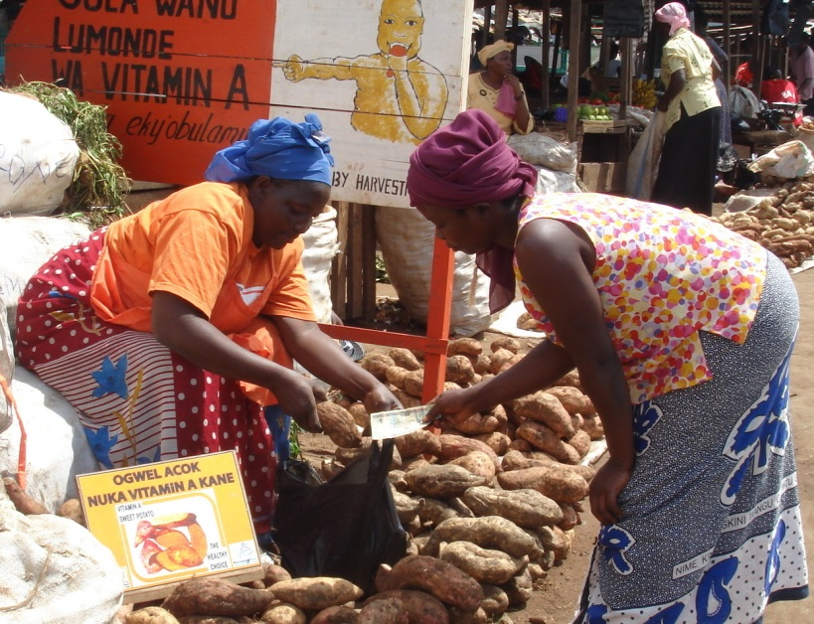

In this photo, a mother feeds her baby orange-fleshed sweet potatoes along with other supplementary vegetables.

Photo Credits: USAID/Uganda

A retailer sells vitamin A-rich orange-fleshed sweet potatoes to a buyer at Kalerwe market near Kampala city. In the left background in a Luganda signpost which, translated in English, reads “Buy Vitamin A-rich potatoes here”
Photo Credits: HarvestPlus, Uganda.

