Every few seconds, the narrow wooden floor creaks as a group of giggling children flow through the corridors of Carnaval Play & Learn, an after-school and summer program in the city of Zarqa, located to the northeast of the capital city Amman. Each laugh and slam of the door is music to Eman Awamleh’s ears, a mother who founded this one of a kind center in Jordan.
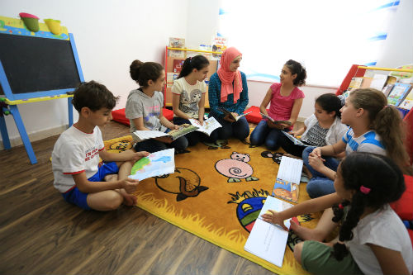
After spending weeks searching for a program that combines fun and a constructive learning experiences to develop the creativity and knowledge of her 2-year-old son Yanal without any luck, Eman decided to design her own curriculum. “I quickly grew frustrated. All the centers were either too expensive or didn’t offer what I was looking for. Plus, all the content that I found online was in English and I knew it just wasn’t the right fit.”
Her friends quickly noticed how effective her curriculum was and started sending their children to her house after school and on the weekends. Shortly afterwards, Eman began to freelance, teaching the program as an extra-curricular activity in various private schools around Amman before signing annual contracts with them. Things were moving quickly for Eman but her own community clearly lacked a program like hers, so she knew she had to open her own center in Zarqa. Five years later, with only 20 Jordanian Dinars and the ability to launch a Facebook page, Eman laid the foundation for what would become Carnaval Play & Learn. Eman had gained enough popularity through social media over the years to apply for a small business grant from the USAID Jordan Local Enterprise Support Project to open up a center that not only benefits youth, but the entire community.
Carnaval officially opened in April 2016 in Zarqa. According to Eman, Zarqa is very industrial and is underserved when it comes to recreational activities for children of all ages, as day care centers are the only available option for toddlers, leaving older children with no place to go to for an after school or summer program.
The idea is simple: a center that teaches children critical and creative thinking and fosters intellectual curiosity through fun activities. It is not unusual to see little kids dressed up as princesses and pirates, while others go up a small rock climbing wall. Eman believes that creative and imaginative play is a natural way for children to learn about the world around them.
Moreover, Carnaval is not just a place that offers an exceptional learning opportunity for children, it is a center that employs around 20 women and students, allowing them to become active members in the economy. It also gives adults the chance to develop skills that can be turned into careers such as drawing, handicrafts and fashion design.
“We encourage stay-at-home mothers to come to the center to take a course. We provide them with all the supplies, and build the schedule around their times of availability with incredibly easy payment terms. And the best part is that their children have a safe place to spend time in while they’re taking their lesson.”
The people of Zarqa were in great need of a center like Carnaval. Some parents even make a 30-minute trip daily just to drop off their kids at the center. “We try to give children an experience that’s unlike anything they’ve ever seen, something they’ll never learn and experience in school or from television.”
Since 2015, USAID’s Local Enterprise Support Project in Jordan has facilitated 83 grants totaling $7.4 million to support the growth of small businesses and improve the long-term economic development of underserved communities. The five-year, $69 million project began in December 2013.

