United States Agency for International Development

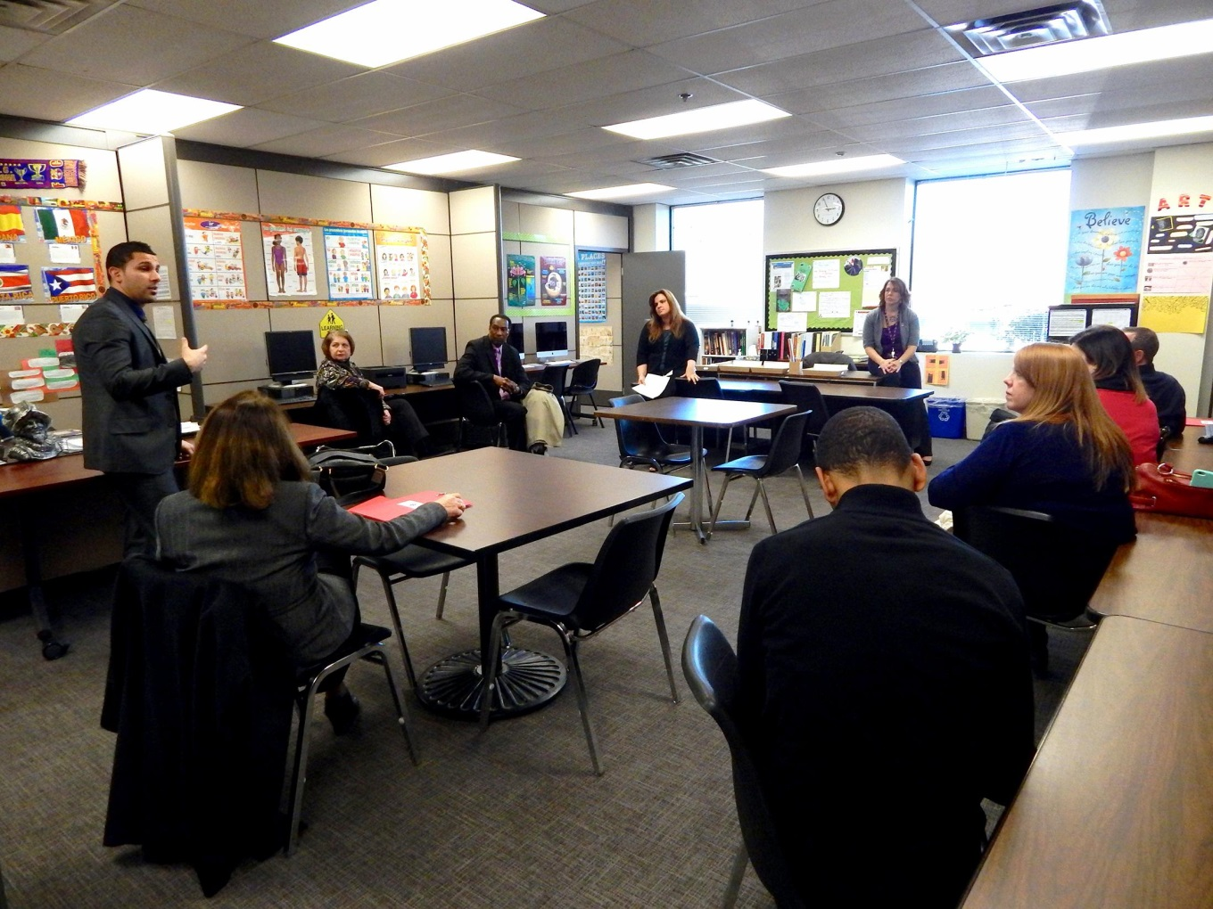
Alternate OPERATIONS Facility
Standard operating Procedures

JANUARY 2016

CONTENTS

Purpose 3
Assessment 4
Location 6
NCC Map 7
Site Access and Check-in 8
Activation Procedures .9
Configuration 12
Telephone Listing 14
Communications 17
Assets 19
Planning Forms and Templates 20
Position Planning Guide 21
Bureau/ Independent Office Contact Information Points of Contact 28
Bureau/ Independent Office Essential Functions 29
Bureau/ Independent Office Succession and Delegation 30
Bureau/ Independent Office Critical Operating Staff 31
Interdependent Points of Contact 32
Reports/Scheduled Events/Issues Log 33
Information Sharing Plan 34
Resource Requirements (System and Communications Assets) 35
Vital/ Essential Records Inventory 36
Alternate Operating Facility Sign in Sheet……………………………….………...37

PURPOSE
The USAID Alternate Operations Facility (AOF) provides an alternate location for the Agency to continue the minimum level of operations as determined appropriate based on events that caused the activation of the Continuity of Operations (COOP) Plan.

The objectives of the USAID AOF include the following:

- Make available an alternate site to continue operations in the event of a disruption to normal operations at the headquarters facility within the NCR;

- Be operational as soon as possible in support of the Agency’s Mission Essential Functions (MEFs).

- Be operational, in all cases within 12 hours of receipt of the initial Continuity of Government Condition (COGCON), if activation is FEMA driven;

- Protect essential equipment, records, and other assets;

- Provide organizational and operational stability. The AOF is capable of maintaining sustained operations until normal business activities can be reconstituted, or for up to 30 days;

- It must be located in an area where the ability to initiate, maintain, and terminate continuity operations is maximized; taking into account distinct power requirements, telecommunications, and distance from the NCR as well as other facilities/locations, including nuclear power plants and areas subject to frequent natural disasters;

- Facilitate decision-making during an emergency;

- Achieve an orderly recovery from emergency operations; and

- Serve as a basis of operations to mitigate additional risks in the event operations could not continue at existing facilities.

ASSESSMENT
USAID has assessed its AOF support requirements per Federal Executive Branch National Continuity Program and Requirements Directive 1 (FCD-1), these include:

Category | Requirement | Available Services | Additional Information
Human Needs | - Billeting, food, water, fuel, medical facilities, and municipal services (e.g. fire, police).  - Capabilities of on-site and/or local first responders.  - Accessibility of transportation for associates or a defined transportation plan that describes procedures for a warning/no warning event. | - On-site lodging, fire, emergency medical services and response team; plus access to Loudoun County Hospital, Fire and EMS services.  - Buffet-style dining.  - Shuttle to/from Dulles International Airport.  - Abundant parking. | - NCC contains a Starbucks and a bar/grill with video games, televisions, and other MWR amenities.  - On-site gym and sports facilities.  - Helipad.  - Convenient local shopping.
Secure Storage | - Capabilities for protecting classified and unclassified vital/ essential records and data-bases. | - On-site SCIF.  - ClassNet  - GSA Approved Safes. | - Essential Records are stored on the USAID shared “V” Drive
Security | - Secure against crime, sabotage, terrorist attack.  - Physical security within 12 hours of COOP activation (perimeter, access, agency internal security requirements).  - Technology for access, surveillance, and early warning of intrusion should be considered. | - Gated community with front gate guards, controlled access list and regular security patrols if required.
Power | - Consider locating AOF in power, telecommunications, and LAN grids distinct from those of the primary facility. | - Located on a separate power and telecommunications grid from the RRB.  - Computer connectivity is maintained to USAID LAN, a backup LAN, and a tape based LAN backup. | - Backup generator.
Communications | - Interoperable communications, including secure communications, with all essential internal and external organizations, customers, and the public.  - Computer equipment, software, and other automated data processing equipment needed for essential functions. | - Secure communications can be conducted in operational areas.  - SCIF is also currently available. | - SCIF use is currently restricted due to proximity to a wireless network. While not optimum, in a National Crisis situation, this issue can be easily overcome.

LOCATION
The USAID AOF is located at the National Conference Center (NCC).

18980 Upper Belmont Place
Lansdowne, VA 20176
(703) 724-5148.

Driving Directions from Washington, D.C., via I-66:
Using the Dulles Toll Road:
Take Constitution Avenue (Route 50 West) to Interstate 66 West. Follow 66 West to Exit 67 to "Dulles Airport/Baltimore and I-495 N." and bear right onto Route 267 West, the Dulles Toll Road (stay in local lanes, not express airport traffic lanes), Remain on the toll road for about 20 miles following signs to the Dulles Greenway West towards Leesburg. Take the Dulles Greenway for about 6 miles, exiting at Route 659 North (Exit 4, Belmont Ridge Road). Proceed on Route 659 North for about 3 ½ miles, (name changes to Upper Belmont Place). Follow signs to the entrance of the NCC located at the end of road.

Using Route 7:
Take Constitution Avenue (Route 50 West) to Interstate 66 West. From 66 West, take Route 7 Northwest (Leesburg Pike) straight for about 22 miles, turn right on Belmont Ridge Road (name changes to Upper Belmont Place). Follow signs to the entrance of the NCC located at the end of road. Speak with the gatehouse security for directions to parking lots and check-in.

Using the Metro:
The NCC provides shuttle buses from Dulles Airport to the NCC (703-724-5129). To get there, the following options are available.

- Take the Metro to the Orange Line in the direction of Vienna/Fairfax/GMU to the Vienna/Fairfax/GMU metro station and take a taxi from there..

- Take Metro bus 5A from L'Enfant Plaza metro station to Dulles Airport;

- The Washington Flyer Coach Service shuttle leaves every 30 minutes from
West Falls Church metro to Dulles, or

- The Super Shuttle will pick you up in D.C. (800-BLUE-VAN (258-3826) or (202) 296-6662) and take you to Dulles.

Taking a Taxi:
The following companies are available - Vienna Cab Co. (703) 938-7272; Falls Church Yellow Cab (703) 534-1111; or Dulles Airport Yellow Cab (703) 437-9100.

NCC MAP
From Route 7
Front Desk
Security
Parking Garage Entrance

SITE ACCESS AND CHECK-IN
Upon Arrival at the NCC Campus:
If a Security Guard is present prior to entry into the campus explain to him/her that you are a member of the USAID Emergency Relocation Group and have been alerted to report to the USAID’s leased space within the North Building.

The guard may or may not have an Entry Authorization List (EAL) on hand to verify that you have authorization to gain access to USAID’s space. If this is the case you may have to call the USAID AOF and request that someone come to vouch for you.
Note: If not on the list, coordinate with the COOP Manager to be added to this list.

- Immediately continue down the road following the signs for the Front Desk.
- Follow the road as it winds around the outside of the NCC campus.
- Take a left as you continue to follow the signs for the Front Desk.
- Veering left, follow the road going up a slight incline.
- Follow the signs for the Parking Garage and park your vehicle.
- Proceed up the hill to the main entrance of the West building across the street from the parking garage and go to the check-in-desk.

Check-in at the NCC
- From the reception entrance (West Building): Report to the reception desk and identify yourself as a member of the USAID Emergency Relocation Group.
- Somebody may or may not be there to greet you and escort you to the AOF.
- Take the elevator to the 4th Floor.
- Follow the signs for the .500 series suites (past the break area). When the walls become orange, take a left into the .500 Suites.
- The AOF is located in connected rooms N4.554-558.
- During a long-term COOP deployment the large adjoining room, N4.586 will be available and can be set up by the NCC within 8 hours.
- If unfamiliar with the NCC Campus, ask Security to escort you to the AOF Nr.554-558 Suite. Or place a call to the USAID AOF and request that someone come to escort you.

ACTIVATION PROCEDURES
CHECK-IN:

First to arrive:
- Request access to the AOF (USAID space) from the NCC Security Office located in the North Administrative Building. (Basement)
  - Security will give you a set of keys and a passcode for the cyber lock after they verify that you are on the Entry Authorization List (EAL). If you are not on the list, you will have to wait until someone that is on the list arrives in order to gain access.
Note: If not on the list, coordinate with the COOP Manager to be added to this list.
- Proceed to the USAID space.
  - Exit the Security Office and follow the hallway on the right (past the hanging mobile statue), go out the door and head left twice on the path into the North building.
  - Take the elevator on the right up one floor to the 4th Floor.
  - Take an immediate left up the stairs and follow the hall straight down (past the break area). When the walls become orange, take a left into the .500 Suites.
  - The AOF is located in connected rooms N4.554-558.
- Utilizing both the keys and the passcode (located on the inside flap of the manila envelope), gain access through the center set of doors.
- De-activate the alarm immediately to your right, by inserting your USAID CAC Card and entering your PIN.
- Turn on lights in all three major spaces.
- Initiate a sign-in roster for arriving personnel, if there is not a template already available, a simple sheet that includes: name, B/IO, contact phone number and arrival time will be sufficient.
- Assist other personnel with check-in as required.

ERG members:
- Sign the ERG Member roster and fill out the requested information.
- Proceed to the USAID space – 4th floor of the North building, rooms N4. 554-558.
  - Note: If necessary ask security to escort you to the proper location.
- Ensure that you are issued an AOF Badge and that you have signed into the USAID Space.
- Move to your assigned location in accordance with the diagram contained within the Configuration Chapter of this SOP.
- Note the specific assignment areas are based on whether or not the additional space (adjacent conference room) has been put into place.
- If there is no assigned seat, then use one of the conference room tables consistent with those duty assignments listed on the diagram.
- Ensure you have sufficient workspace to accomplish your mission.
- If you are not familiar with the NCC, ensure you have a copy of the pre-positioned Orientation Packet showing locations of necessary facilities.
- Create a duty log for your assigned mission to capture all significant activities that take place during your duty period.
- Log in to the laptop or desktop computer at your workstation (if applicable) and verify access to e-mail, internet, and vital records.
- Note: If any of your systems are not working properly, a CIO representative should be available to assist.
- If you have not been to the site for an extended period of time, it may take some time for your profile to download.
- Check the telephone at your workstation to ensure that you can place outgoing calls.
- Review the ERG Position Planning Guide for your position.
- Contact Subject Matter Experts (SMEs) within your B/IO and advise them of your location.
- Contact interdependent partners, agencies, missions or other organizations that would need to know where to contact you.
- Begin conducting Essential Supporting Activities (ESAs) in support of the Agency’s MEFs.
- Standby to participate in meetings led by the Administrator, Continuity Coordinator or Reconstitution Team Leader as required.
- Be prepared to relocate to the Primary Operating Facility (POF), a Temporary Operating Facility (TOF), or a new or rebuilt operating facility.

COOP Coordinator/ Manager:
- Call the FEMA Operation Center (FOC), (540) 665-6100/1-800-634-7084, to notify that USAID has activated its COOP Plan and achieved the designated COGCON level if applicable.
  - Note: This action is taken regardless of agency location and the time of execution or activation of B/IO call-down trees.
  - The FOC will relay this information to the National Operations Center (NOC) and the Office of National Security Coordination (ONSC). The FOC will notify USAID of any additional reporting requirements.
  - Note: This initial action is normally undertaken by the Continuity Manager through a FEMA specific portal known as the Cross Domain Solution utilizing a FEMA issued RSA token.
  - M/MS/HMD has two individuals assigned as backup with additional tokens if necessary.
- If the activation was directed by FEMA, ensure that a Continuity Status Report (CSR) is electronically submitted through the Cross Domain Solution (CDS) using the CDS Token for access.
- Report the status of relocation to other agency points-of-contact, including DOS, using the Interagency COOP Contact directory (found in the AOF safe, classified Secret).

Security:
USAID Security coordinates with NCC Security for all security issues including:
- Security sweep of USAID space.
- Any need for perimeter security.
- Reception and in-processing of ERG personnel.
- Secure any classified materials in appropriate safe, following established procedures for handling classified materials.
- Provide access to safes for ERG members as necessary.
- Set up mail, cable, and periodical delivery schedule.
- Set up courier runs to DOS and other agencies, as applicable.
- Provide for mail diversion and security scanning.

CIO:
- Through coordination with NCC staff, assist in the setup of workstations in the additional space/ conference room (as needed for a long-term activation).
- Check phone lines, televisions, and configure computers, as necessary.
- Assist USAID personnel as required.

CONFIGURATION
The USAID AOF is situated in the North Building in connected Rooms N4.554-558 and N4.586. The following diagrams are provided to orient ERG members to the space.

Short-term activation:
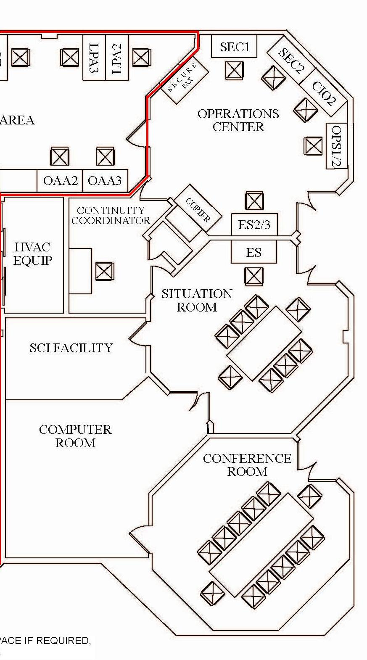
N4-586
N4-558
Site Entrance Doors
N4-554
N4-556
COOP
During a long-term COOP event the large adjoining room, N4.586 will be available and set up by the NCC within 8 hours. (Red box)

Long-term activation: 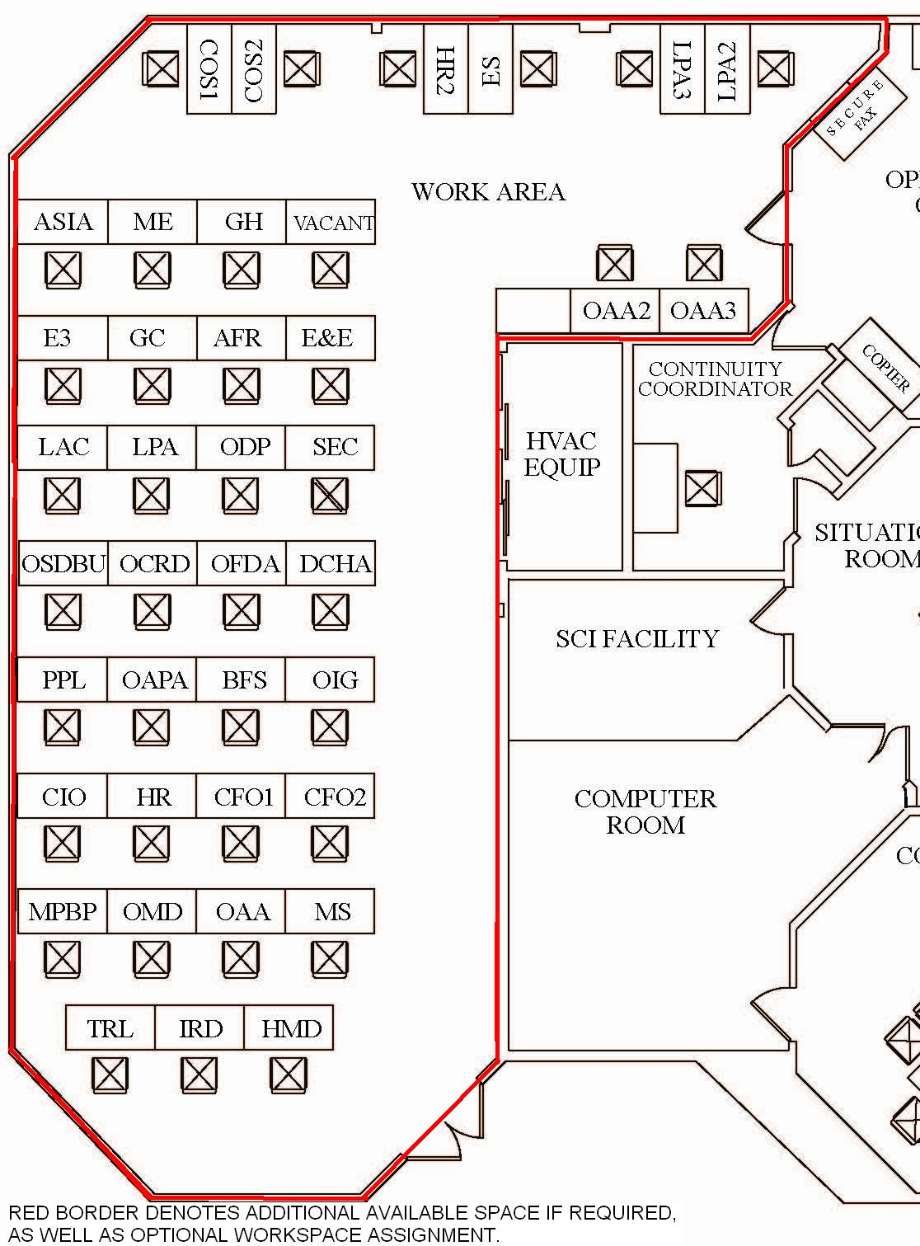
HCTMM
HCTM2M
N4-586
M
OST
CFO
TTD

TELEPHONE LISTING
To dial out of the building, press 8 - Do not press 1 first. There is no long-distance or international code required. For international dialing, press 8-011, the country code, city code, and the number (e.g., the embassy in Bern, Switzerland would be 8-011-41-31-357-7011).

All desk phones were installed in the directory by their B/IO name. This function is especially useful when the AOF has been expanded beyond the ERG for long-term operations. USAID staff can utilize the directory function by pressing the “Directory” button, key in “AID” to reach the USAID phones in the NCC phone directory, and then press the “Next” button until the desired USAID phone is displayed, press the “Call Displayed” button to dial the desired phone.

Organization | Assigned Seat | Telephone
Administrator | Office (conference room) | (703)724-6891
 | Secure Phone (STE) | (703)724-0639
Operations Center | COOP Coordinator | (703)724-6805
 | Exec Sec-1 | (703)724-6830
 | Exec Sec-2 | (703)724-6816
 | COOP-1 | (703)724-6810
 | CIO-1 | (703)724-6820
 | SEC-1 | (703)724-6812
 | SEC-2 | (703)724-6814
 | Ops Center Fax | (703)724-6811
 | Ops Ctr Secure Fax/Secure Phone (STE) | (703)724-9768
 | COOP Room (STE) | (703)724-0970
Staff  Staff | M | (703)724-6850
 | OFDA | (703)724-6852
 | DCHA | (703)724-6853
 | E3 | (703)724-6854
 | GH | (703)724-6855
 | AFR | (703)724-6856
 | ASIA | (703)724-6857
 | E&E | (703)724-6858
 | ME | (703)724-6859
 | LAC | (703)724-6860
 | OIG | (703)724-6861
 | CIO-2 | (703)724-6862
 | CFO | (703)724-6863
 | OSDBU | (703)724-6864
 | PPL | (703)724-6865
 | OCRD | (703)724-6866
 | ODP | (703)724-6867
 | GC | (703)724-6868
 | OAPA | (703)724-6869
 | M/MS | (703)724-6870
 | M/OMD | (703)724-6871
 | M/IRD | (703)724-6872
 | HCTM-1 | (703)724-6873
 | HCTM-2 | (703)724-6874
 | LPA-1 | (703)724-6875
 | LPA-2 | (703)724-6876
 | LPA-3 | (703)724-6877
 | TTD | (703)724-6878
 | MPBP | (703)724-6879
 | OAA-1 | (703)724-6880
 | OAA-2 | (703)724-6881
 | OAA-3 | (703)724-6882
 | COS-1 | (703)724-6883
 | COS-2 | (703)724-6884
 | HMD | (703)724-6885
 | BFS | (703)724-6886
 | OST | (703)724-6887
 | COOP-2 | (703)724-6888
 | COOP-2 | (703)724-6888
Other Telephone Numbers
General AOF Numbers | Situation Room 1 (SR-1) | (703)724-6889
 | Situation Room 2 (SR-2) | (703)724-6890
 | Computer Room (CR-2) | (703)724-6802
 | FEMA Operations Center (FOC) | (540)665-6100  (800)634-7084
 | National Operations Center (NOC), FEMA Desk | (202)282-8131
 | NCC Fire Department/Emergency Medical Service, NCC Emergency Response Team | (703) 729-8000 #41100 (Security)
 | NCC Business Center | (703)724-6282
 | NCC Catering | (703)724-6219
 | NCC Starbucks | (703)724-6290
 | Loudoun County Sheriff’s Office | Dispatch (703)777-1021  (703)777-0407
Area Important Numbers | Leesburg Town Police | (703)771-4500
 | Loudoun Hospital (44045 Riverside Parkway, Leesburg VA) | Switchboard (703) 858-6000
 | Fire/EMS Company 20 | (703)777-9103
 | Loudoun Rescue Company 13 | (703)777-7185
 | Dulles Airport | (703)572-2700
 | Leesburg Executive Airport | (703)737-7125
 | VA Army National Guard | (703)771-2500
 | Office Depot Leesburg | (703)737-3322

COMMUNICATIONS
No classified conversations can take place in the expanded (long-term) space. For proper security procedures for classified conversations, refer to SEC.

Operating Instructions for the STE Secure Telephone
and Ilex Secure Facsimile Machine

SECURE PHONE:

(Note: On the secure telephones, dialing an “8” is not required to get outside the NCC.)

- Insert the KOV-14 crypto card into the front slot (white label side up and small triangle pointing away from you). The KOV-14 cards are kept in the AOF safe. Contact the USAID COMSEC custodian for access.

- Ensure that the “card inserted light” is solidly lit (not flashing) and make sure you have a dial tone.

- Dial your distant party (or he/she can call you).

- Press the corresponding blue button under SECVOICE. (Note: both secure phones should be attempting to synchronize (handshake). You should hear a few modem tones.)

- Once both ends have synchronized, your display will have the distant-ends crypto card information displayed on your phone (and vice versa). Look for SV2.4 or SV 4.8 in the upper right hand corner of your display.

- Begin secure conversation.

- Once the conversation has concluded, put the handset back onto the cradle.

- Once the display has cleared (very important), the KOV-14 crypto card can be ejected by pushing the ejection button to the right of the slot AND SECURED in the SAFE if phone will no longer be used. (Caveat: For an exercise/event, the crypto card(s) can be left in the secure phones, as long as someone from the ERG is present. Someone must be responsible.

SECURE FACSIMILE MACHINE:

- Follow steps one through four above.

- Once secure voice has been established and you have identified the number pages being sent or received, press the corresponding blue button under SECDATA. (Note: You are in secure date mode, when you see SD2.4, SD 4.8 or SD 9.6 in the upper right hand corner of your display.)

- If you are sending a document, then place it face down in the document tray.

- Press the Red SEND button and the Gray START button. (Note: the facsimile display should indicate ON-LINE XMT.)

- Do not hang up the handset (place on table or hold).
- Once transmission has completed and the facsimile display no longer displays ON-LINE XMT, press secure voice or none secure button to confirm receipt of the pages.

- If you are receiving a document, follow steps 1 – 3 listed under the Secure Phone section, and then press the corresponding blue button under SECDATA. (Note: both secure phones should be attempting to synchronize (handshake). It does not matter which end presses the secure voice or secure data buttons.

- Once the distant end has begun transmitting the document, you should see ON-LINE RCV on your fax display.

- Once the data transmission or conversation has concluded, put the handset back onto the cradle.

- Once the display has cleared (very important), the KOV-14 crypto card can be ejected by pushing the ejection button to the right of the slot AND SECURED in the SAFE if phone will no longer be used. (Caveat: For an exercise/event, the crypto card(s) can be left in the secure phones, as long as someone from the ERG is present. Someone must be responsible.

ASSETS
USAID has assessed its requirements for information technology interoperability equipment required at the AOF. These critical requirements are listed below:

Inventory
40 Laptops
14 Desk-based workstations.
Desks and chairs to seat 68 (long-term). Additional space can be acquired from the NCC.
49 telephones, positioned at each workspace and in the enclosed rooms.
Backup email servers
Secure telephone
Secure fax
GSA approved safe
Shared workspace access to two printers and one fax machine.
Shredder
AIDNET connectivity
Pre-positioned office supplies
Portable audio visual projector
Six televisions with DVD and VHS capability connected to NCC’s Cable Television System
A satellite dish at the facility ensures a backup for computer accessibility.

Note: Heating and air conditioning can be controlled via a thermostat located in room 4.554.

________PLANNING FORMS AND TEMPLATES_______
Each ERG member position has an associated Position Planning Guide (PPG) developed in order to ensure other ERG members or Devolution ERG members are able to perform the same support function of the position if necessary.
Please refer to the PPG that was developed for your assigned position. A blank form is provided here as an example:

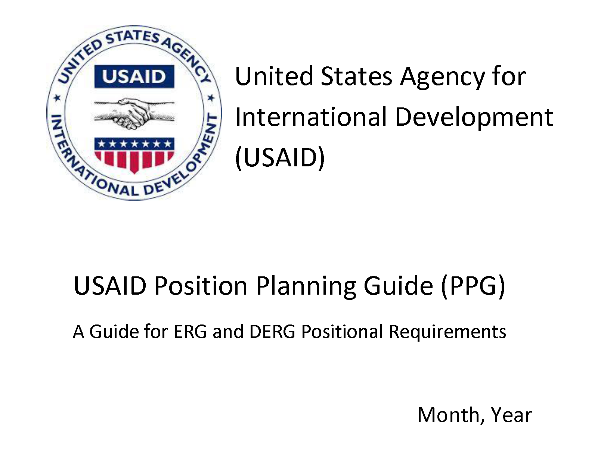

Position Planning Guide (PPG)

Regardless of the type of incident, it is imperative that USAID be able to perform its Mission Essential Functions (MEFs). You were selected to be a member of the Emergency Relocation Group (ERG) because you support the performance of USAID’s MEFs. Each function which supports a MEF will have a Position Planning Guide (PPG) developed in order to ensure other ERG members or Devolution ERG members are able to perform the support function if necessary.
The attached forms and templates are an aid to assist you in identifying:
- Qualifications the person filling your ERG position must have (clearance level, knowledgebase, etc.)
- How this support function supports the MEF
- What information is needed in order for decisions to be made and how quickly this information must be received
- Where the information comes from (position, organizations, etc.) and when it will be received
- How this information is pertinent to accomplishing your support function and what you do with the information/how it is used
- With whom should this information be shared (position, organization, etc.)
- What equipment and resources are needed (databases, software, etc.).
Accurately completing these forms and templates will not only verify what you need to do to accomplish your support function, it will also assist other ERG members in identifying their responsibilities should they need to assume the duties of this position. These forms should be completed with as much depth and detail as possible. The goal of the PPG is to enable a less familiar staff member to perform the roles and responsibilities of an ERG position with minimal downtime, which can only be accomplished by providing extensive information.
The information you capture on the attached forms will be used to strengthen the readiness of the USAID ERG and help ensure MEFs are able to be supported in any situation.

Purpose and Instructions
Purpose: The purpose of this document is to capture specific information about your support function, what skill sets and qualifications are required, where these duties are performed, what are the primary tasks, and what resources are needed to perform the tasks.
Instructions: Fill in the requested information, below. For all “check boxes” right click on the box, select “properties,” then select “checked.”
Support Function Position Title
B/IO
Position AOF Phone
Position E-mail (List all e-mail groups associated with this position)
Which ERG members also support this function |  | Primary team member name(s): |  |  |  |  |  |  | Contact information (phone, blackberry, email):
 |  | Secondary team member name(s): |  |  |  |  |  |  | Contact information (phone, blackberry, email):
 |  | Tertiary team member name(s): |  |  |  |  |  |  | Contact information (phone, blackberry, email):
Is this position filled by a Federal Employee or Contractor? If both, please indicate.
Federal Employee | Contractor
Grade level and series of Federal Employees (e.g., GS15-301)
What is the security clearance level needed to support this function? |  |  |  |  | Secret
 |  |  |  |  | Top Secret
 |  |  |  |  | Top Secret / Sensitive Compartmented Information (SCI)
Which MEF(s) is/are supported by this function?

- Provide assistance to the Department of State in coordinating international offers for health and medical support as required by the National Response Framework.

- Assist in the coordination of Urban Search and Rescue as required by the National Response Framework.

- Support relief and response operations to natural and/or man-made international disasters.

- Provide guidance and support operations to field missions in an effort to foster effective relationships with foreign nations.

How soon after activation must this task be resumed? (check appropriate box)
 | Immediate (0 hours delay) |  |  |  |  |  |  |  | Within 1 Week
 | Almost Immediate (< 4 hrs.) |  |  |  |  |  |  |  | Within 2 Weeks
 | With Minimal Delay (<12 hrs.) |  |  |  |  |  |  |  | Within 30 Days
 | Within 48 Hours |  |  |  |  |  |  |  | Within 90 Days
 | Within 72 Hours |  |  |  |  |  |  |  | No Significant Time Constraint
ERG position description: (An overarching statement addressing your position – In your own words, what do you do during a USAID COOP Plan activation to support USAID MEFs?)

Where does this function relocate? (Do not list classified locations)  Indicate AOF seat location (if known) |  |  |  | AOF - NCC |  |  |  |  |  |  | Seat number:
 |  |  |  | Other (specify: e.g., telework) |  |  |  |  |  |  | Seat number:
Should this position be  considered for telework options? |  |  |  | Yes No  If yes, why?
Is proximity to leadership required? |  |  |  | Yes No  If yes, why?
Does this position supervise other ERG Staff? |  |  |  | Yes No  If yes, how many?
What ERG position has supervisory responsibility over this position?
Is specific guidance or clearance needed to supervise this staff? |  |  |  | Yes No  If yes, explain.
Do the current ERG members listed to support this function have the authority to carry out the roles and responsibilities of the position? (E.g. delegated authority, contracting authority, etc.) |  |  |  | Yes No  If no, explain.
Is special training, certification, or skill sets required for this position? (e.g., contracting authority, technical requirements, etc.) |  |  |  | Yes No  If yes, explain.
Position resource requirements. What resources are needed to perform the duties of this function? Include equipment (including IT/communications), essential records (electronic and hardcopy), safety/environmental considerations, software packages, supplies, GIS/maps, etc. Include business Drive-Away Kit requirements.
(The terms To-Go-Kit, Go-Kit, Fly-Away Kit and Drive-Away kit are all used interchangeably and they can be utilized to serve several needs such as: required items for personal needs for an extended period of time, or for a separate kit stored in a vehicle or office)

A LAN Q-Sec Phone Homeland Security Information Network (HSIN) Access

B LAN STE Radios (specify type)

C LAN Satellite Phone Wireless Priority Service (WPS)

Pager Landline Government Emergency Telephone Service (GETS)

BlackBerry Desktop/ laptop Other (specify)

Access Requirements

Does the designated workstation have the appropriate hardware and applications to perform the function? |  |  |  | Yes No  If no, what is needed?
List any special software applications you need to support this function.

Drive Away Kit
(The terms To-Go-Kit, Go-Kit, Fly-Away Kit and Drive-Away kit are all used interchangeably and they can be utilized to serve several needs such as: required items for personal needs for an extended period of time, or for a separate kit stored in a vehicle or office)
The Drive Away Kit contains key organizational reference information and equipment that can be quickly retrieved and taken to the AOF. Each ERG member is responsible for assembling and maintaining a Drive Away Kit. The contents of the kit should be reviewed on a quarterly basis and updated as necessary. Select all Drive Away Kit items below that are currently included in this position’s kit.
 | Directions to AOF |  |  |  |  |  |  | Government Emergency Telecommunications Service (GETS) card
 | Telephone rosters |  |  |  |  |  |  | Emergency plans, rosters, documents
 | Organization and functions manuals |  |  |  |  |  |  | Security clearance rosters
 | Personnel contact lists |  |  |  |  |  |  | Government credit card
 | External customer listing & contact information |  |  |  |  |  |  | Emergency procurement authorities
 | Laptop computer/Air Card (incl. power cord) |  |  |  |  |  |  | Building floor plans
 | Satellite phone (incl. charger) |  |  |  |  |  |  | Equipment inventories
 | Pager/BlackBerry/cell phone (incl. charger) |  |  |  |  |  |  | Emergency equipment:
 | Government travel card |  |  |  |  |  |  | Other:
 | Information Technology (IT) systems documentation |  |  |  |  |  |  | Other:

Function/Task Description
(In this section, provide details and further information as to the specifics of what is involved with performing this function.)
ERG Position Title:
Task Description. For the USAID MEF you support, list your major roles, responsibilities, and tasks.
MEF: | Roles:
 | Responsibilities:
 | Tasks:

Bureau/ Independent Office Contact Information Points of Contact
(This section can be supplemented with a call-down roster or organizational chart.)

Name | Office | Office Phone Number | Home Phone Number | Mobil Phone number | Email Address | Alternate Email Address

Bureau/ Independent Office Essential Functions
(List those essential functions that must be continued in an emergency in support of the MEFs.)

Essential Function | Task/Action Description | Involved organizations / elements and personnel | Primary Resources | Remarks

Bureau/ Independent Office Succession and Delegation
(This section is reserved for succession and delegation information.)

Name | Office | Office Phone Number | Home Phone Number | Mobil Phone number | Email Address | Alternate Email Address

Bureau/ Independent Office Critical Operating Staff
(This section is reserved for critical operating staff or Subject Matter Experts that may be called upon while working remotely from home or a telework site.)

Name | Office | Office Phone Number | Home Phone Number | Mobil Phone number | Email Address | Alternate Email Address

Interdependent Points of Contact
(List external agencies, partners, missions, etc.)

Organization | Point of Contact | Phone Number | Cell Phone | Fax | Email Address | Alternate Phone Number

Reports/Scheduled Events/Issues Log

Date or Frequency | Time | Report or Event | Supporting Information Sources | Responsible Office | Receiving Offices | Completed / Remarks

Information Sharing Plan

Information Requirement | Essential Elements of Information | Methodology / Sources | Responsible Elements | Deliverable | Collection Suspense | Distribute To

Resource Requirements

(System and Communications Assets)

System Type | System Name | Associated Number, Frequency, Channel, etc. | Additional  Information

Vital/ Essential Records Inventory

(The terms Vital and Essential as they apply to Continuity Records are used interchangeably.)

Vital Records Type  (Electronic / Hardcopy) | Document, Form, Template Name | Vital Records Location  (Shared Drive / Directory or Physical Room/Drawer) | Access Requirements/ Additional  Information

Alternate Operating Facility Sign-in Sheet
First, Last Name | B/ IO | Contact Information | Continuity Function | Time  In | Time  Out | Additional  Information

