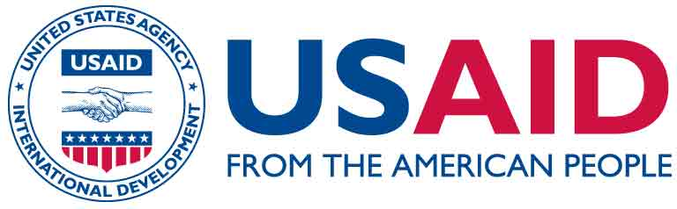
USAID/OFDA Proposal Guidelines
Pharmaceutical Annex E
December 2015

Instructions to Purchase Pharmaceuticals and Kits (that include Pharmaceuticals) from a Non-USAID/OFDA Prequalified Pharmaceutical Wholesaler

Implementing partners often wish to purchase pharmaceuticals from local sources using USAID/OFDA funds (i.e., a non-USAID/OFDA prequalified pharmaceutical wholesaler). This practice is problematic because the safety, efficacy and quality of the pharmaceuticals from these sources have not been evaluated by USAID/OFDA. Please be advised that no USAID/OFDA funds may be awarded until the wholesaler is approved for the purchase of human or veterinary pharmaceuticals. The collection and submission of the information required may add weeks, if not months, to the approval process, depending on the responsiveness of the wholesaler.

Instructions for requesting to purchase pharmaceuticals and kits (that include pharmaceuticals) from a non-USAID/OFDA prequalified pharmaceutical wholesaler:

- If a partner is requesting to purchase pharmaceuticals from a non-pre-qualified wholesaler, the specific wholesaler (that provided the cost quote) must be identified.

- A complete list of the pharmaceuticals must be provided. See Annex D on the OFDA Resources page for the information that is required by USAID/OFDA.

- English language translations of the following documents must be submitted:
- Complete address and contact information of the pharmaceutical supplier;
- Website, if available;
- Product catalog and price list;
- Organizational chart (list of principals and their titles);
- Government documents authorizing the sale of pharmaceuticals (current licenses and/or permits);
- A list of the organizations that have inspected the pharmaceutical wholesaler within the past 24 months;
- Copy of the wholesaler’s quality assurance program (e.g., standard operating procedures);
- List of the individuals responsible for the quality assurance of pharmaceuticals;
- Procedures or process used to select inventory of the wholesaler;
- Computerized invoices, packing lists with batch numbers and delivery notices;
- Certificates of Analysis for each batch of each pharmaceutical product purchased;
- Assurance that the expiration policy states that no pharmaceuticals will be sold within 12 months prior to the expiration date; and
- Photographs of exterior of warehouse, storage areas, signage, windows, delivery and shipping docks, cold storage facility, temperature monitors, shelving systems, and pest control measures.

- Assurance to USAID/OFDA that the national Ministry of Health (MoH) or other responsible government body has approved this partner to import (if necessary) the required pharmaceuticals without imposition of duties, fees, handling charges and for their humanitarian use in the country.

Template (Letter) to Purchase Human Pharmaceuticals and/or Kits (containing Pharmaceuticals) from Non-USAID/OFDA Prequalified Pharmaceutical Wholesaler

Partners should submit the request on organizational letterhead and the request should not exceed two (2) pages. Partners may use the following template:

[Insert organization letterhead]

Date: [insert date letter submitted]

Ref: [insert name of your organization] hereby requests approval to purchase non-U.S. Food and Drug Administration (FDA) approved pharmaceuticals for our program [insert program title] in [insert country].

Dear [Insert name of USAID/OFDA Program Specialist],

Background: [insert a short statement of what you are attempting to accomplish with this program]

To ensure sufficient supplies of pharmaceuticals needed to treat [insert a list of the medical conditions that will be treated], [Insert name of organization] proposes to use [insert the amount in USD] of USAID/OFDA funds to purchase pharmaceuticals (and/or kits) from the following non-USAID/OFDA prequalified pharmaceutical wholesaler, [Insert name and address of wholesaler].

[Must include an explanation of why this wholesaler was selected, any previous history of purchasing medicines through this wholesaler, and availability of pharmaceutical commodities, etc.]

Attached is a list of the pharmaceuticals (and/or kits) required for this project as well as all required supporting documentation to demonstrate the safety, efficacy, and quality of each pharmaceutical product; along with documentation to demonstrate the quality assurance program of the proposed supplier.

Also included is a copy of the letter from [insert the name of the Ministry of Health (MoH) or other responsible entity] granting approval for the importation, if needed, of the required pharmaceuticals without imposition of duties, fees, or handling charges and for their humanitarian use in the country.

Sincerely,

(Insert Signature and Date)

