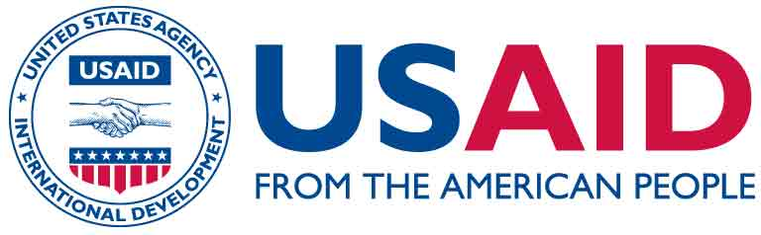
USAID/OFDA Proposal Guidelines
Pharmaceutical Annex C
December 2015

Instructions and Template to Purchase Pharmaceuticals and Kits (that include Pharmaceuticals) from a USAID/OFDA Prequalified Pharmaceutical Wholesaler

Instructions to purchase pharmaceuticals from a USAID/OFDA prequalified pharmaceutical wholesaler:

- The following commodities are considered restricted goods by USAID. As such, partners must submit a formal request for approval to purchase any of these commodities:
- Pharmaceuticals – human (or veterinary)
- Oral Rehydrating Salts (ORS)
- Rapid Diagnostic Tests
- Kits that contain any pharmaceuticals

- USAID/OFDA has recognized several pharmaceutical wholesalers that are consistently able to provide safe, effective and quality essential medicines and other medical commodities (see Annex G on the OFDA Resources page).

- Before a partner can request pharmaceuticals and kits from a USAID/OFDA pre-qualified wholesaler, the following template letter and Annex D must be completed. Information in these Annexes must include: the name of medication, strength/dose, quantity, intended use within the scope of the program, cost per unit, extended cost, and total cost. In addition, all selected pharmaceuticals must be based upon the OFDA Essential Medicine List (EML) on the OFDA Resources page.

- If the pharmaceutical wholesaler is not a USAID/OFDA prequalified pharmaceutical wholesaler, refer to the instructions in Annex E on the OFDA Resources page for a template of the letter requesting to purchase from a non USAID/OFDA prequalified pharmaceutical supplier, as well as a list of the additional documentation required. This process may require weeks or months depending on the responsiveness of the wholesaler.

- Lastly, partners must provide assurance (i.e., copy of the letter) to USAID/OFDA that the national Ministry of Health (MoH) or other responsible government body has approved the partner to import, if needed, the required pharmaceuticals without imposition of duties, fees, or handling charges and for their humanitarian use in the country.

Template Request Letter to Purchase Human Pharmaceuticals and/or Kits (containing Pharmaceuticals) from USAID/OFDA Prequalified Pharmaceutical Wholesaler

Partners must make the request on organizational letterhead and the request should not exceed two (2) pages. Partners may use the following template:

[Insert organization letterhead]

Date: [insert date letter submitted]

Ref: [insert name of your organization] hereby requests approval to purchase non-U.S. Food and Drug Administration (FDA) approved pharmaceuticals for our program [insert program title] in [insert country].

Dear [Insert name of USAID/OFDA Program Specialist],

Background: [insert a short statement of what you are attempting to accomplish with this program]

To ensure sufficient supplies of pharmaceuticals needed to treat [insert a list of the medical conditions that will be treated], [insert name of organization] proposes to use [insert the amount in USD] of USAID/OFDA funds to purchase pharmaceuticals (and/or kits) from [insert name USAID/OFDA pre-qualified wholesaler].

Attached is a list of the pharmaceuticals (and/or kits) required for this program.

Attached is a copy of the letter from [insert the name of the Ministry of Health (MoH) or other responsible entity] granting approval for the importation, if needed, of the required pharmaceuticals without imposition of duties, fees, or handling charges and for their humanitarian use in the country.

Sincerely,

[Insert Signature and Date]

