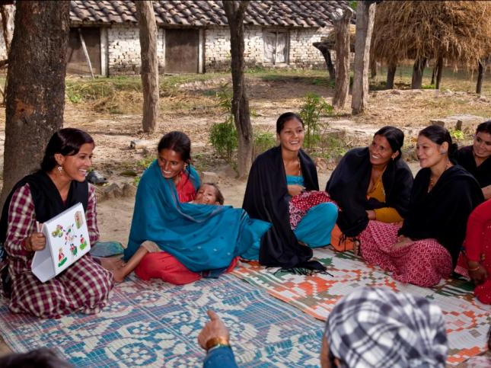
Health and Family Planning Program
SUAAHARA Project – Good Nutrition
USAID/Nepal’s Suaahara project works closely with the government to strengthen policies and programs that will improve the health and nutritional status of women and
Suaahara works with Female Community Health Volunteers and mothers’ groups to improve the health and nutrition behaviors of mothers, infants and young children.

SNAPSHOT
Life of Project: August 2011 to August 2016
Goal: The health and well-being of Nepalis is improved and sustained.
Implementing Partners: Save the Children, in coordination with Helen Keller International, Jhpiego, Johns Hopkins Bloomberg School of Public Health Center for Communication Programs, the Government of Nepal Ministry of Health and Population, NEWAH, NPCS, and NTAG
Geographic Focus: 20 districts of Nepal

children.
Nepal is on its way to achieving Millennium Development Goals (MDGs) 4 (“Reduce Child Mortality”) and 5 (“Improve Maternal Health”). The MDG Summit in New York held in September 2010 formally recognized the progress that Nepal had made in reducing its maternal mortality rate from 539 to 281 per 100,000 live births between 1996 and 2006. Nepal was selected from among 49 countries for this honor. Similar progress has been made in reducing child mortality as Nepal was selected as a Global Alliance for Vaccines and Immunization (GAVI) country award recipient in 2009 for the highest average annual rate of reduction in child mortality since 1990 among all of the 72 GAVI countries.
Nepal has also made significant progress to control deficiencies in micronutrients such as Vitamin A, iron and iodine. Despite these successes, however, malnutrition rates in Nepal remain high. Nepal is one of the most undernourished countries in the world, and poor nutrition is a major public health problem across the country’s rural areas. Over 40 percent of children under five suffer from stunting, 11 percent suffer from wasting, and 29 percent are underweight. In addition, 44 percent of the population does not have access to toilets and thus practices open defecation, which contributes to high diarrheal disease morbidity with detrimental effects on nutritional status. Socio-economic, geographic, and educational factors, along with regressive gender norms, all contribute to poor health status, primarily among women and children.
PROJECT OVERVIEW
USAID has made substantial contributions to health and nutrition in partnership with the Government of Nepal (GON) and other external development partners. As part of its strategy to strengthen the country’s health and nutrition programs, USAID, in consultation with the Ministry of Health and Population (MOHP) and relevant partners, designed the Integrated Nutrition Project --‘Suaahara’ (Good Nutrition).

Suaahara is a five-year, $46 million comprehensive community-focused project dedicated to improving the health and nutritional status of pregnant and lactating women and children under two years of age, thereby directly addressing the vulnerable points of development which result in chronic undernutrition or stunting. The project focuses on improving: nutrition; maternal, newborn, and child health (MNCH) services; reproductive health/family planning services; water, sanitation and hygiene; and home-based gardening in 20 districts.

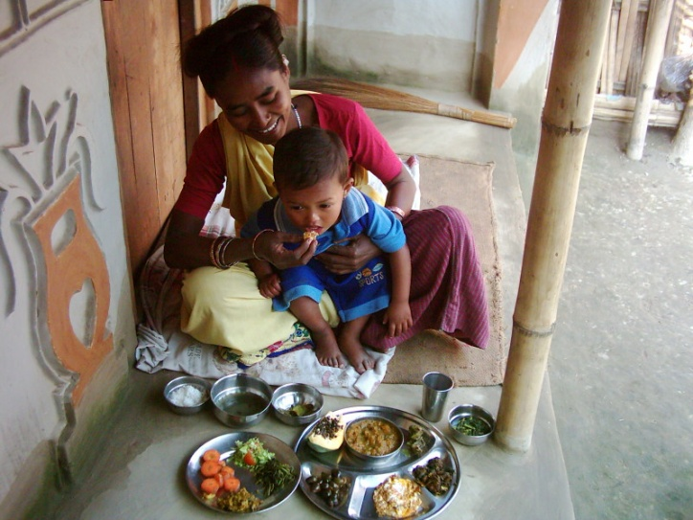
The project works within the government system, primarily through Female Community Health Volunteers (FCHVs) and other community extension workers. FCHVs disseminate health messages, services and commodities at the household level and through mothers’ group discussion forums. For 20 years, the GON, other donors, and USAID have increased the knowledge and skills of this cadre of FCHV’s and their female neighbors through a family health-based curriculum. The volunteers are now building on that knowledge and developing demonstration farms encompassing poultry farming, productive sanitation, integrated pest control and nutritious vegetables.
Suaahara will improve dietary diversity of mothers and children through homestead food production

Suaahara integrates health, nutrition, agriculture and food security activities. Complementary nutrition and hygiene education, small-scale backyard farming, and greater access to and understanding of the need for a variety of healthy foods will improve the impact of agriculture production and economic development on nutritional status in the Mid- and Far-West regions. Project approaches support the Government of Nepal’s Multisectoral Nutrition Plan 2013-17 and the Hygiene and Sanitation Master Plan 2011-2015.
As one of only a few comprehensive, community-based integrated nutrition programs in the world, Suaahara has the potential to pilot innovative approaches that could be replicated elsewhere.
PROJECT ACTIVITIES
- Provide training on a package of integrated and evidence-based essential nutrition actions for health and non-health service providers, Female Community Health Volunteers, mothers’ groups, and household decision makers, especially mothers-in-law and husbands.
- Support improvements in nutrition and maternal and child health services through a focus on quality improvement.
- Promote good water, sanitation and hygiene practices at the household and community level in support of GON efforts to achieve “open defecation-free” status for key districts.
- Enhance health workers’ capacity to provide effective counseling on healthy timing and spacing of pregnancy as critical for good health and nutrition.
- Mainstream homestead food production activities (vegetables and backyard poultry farming) to increase year-round access to diverse and nutritious foods at home.
- Enhance multi-sectoral coordination on nutrition between the GON and others actors for the effective planning, implementation and monitoring of integrated nutrition activities via technical assistance to national working groups.
PLANNED OUTCOMES
CONTACT
U.S. Agency for International Development
G.P.O. Box 295, Brahma Cottage, Maharajgunj, Kathmandu, Nepal
Tel: 977-1-4007200
Fax: 977-1-4007285
Email: usaidnepal@usaid.gov
www.usaid.gov/nepal
www.facebook.com/usaidnepal
www.twitter.com/usaidnepal
Save the Children
4th floor | Airport Gate, Sinamangal, Kathmandu, Nepal
Tel: +977-1-4468128-32
Email:lala.borja@savethechildren.org
Web: www.savethechildren.net

- Reduce the prevalence of stunting, wasting and underweight among the children under two years of age in 20 target districts.
- Improve infant and young child feeding practices.
- Increase the consumption of diverse and nutritious foods by pregnant and lactating women and their families.
- Increase the use of quality health services, especially for the management of diarrhea and acute respiratory infections.
- Improve the utilization of quality maternal health services.
- Reduce the prevalence of diarrhea among children under five years of age.
- Increase the number of households using improved drinking water sources.
- Increase the number of households using improved sanitation facilities.
- Strengthen multi-sectoral coordination on nutrition among GON ministries and other stakeholders.
- Increase the number of USAID-supported service delivery sites that offer family planning services.

