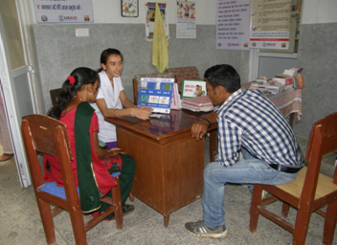
Health and Family Planning Program
Health worker provides family planning counseling to a couple in the Primary Health Care Center.

Direct Government-to-Government Support to the Ministry of Health and Population
The Government of Nepal’s Ministry of Health and Population (MOHP) has seen award-winning success in improving maternal and infant health across the country. The Ministry is on track to achieve Millennium Development Goals 4 “Reduce Child Mortality” and 5 “Improve Maternal Health” and continues to strive to realize further accomplishments in the areas of maternal, newborn and child health. To build on these successes, USAID provides direct funding to strengthen MOHP staff capacity and management systems with the end goal of improving quality and access to services focused on marginalized and vulnerable communities. Through this direct funding approach, USAID leverages host country systems and personnel to reach people who have the greatest need for quality maternal and child health services.
SNAPSHOT
Life of Project: 2013 - 2019
Goal: Support MOHP to provide sustainable, accessible and quality family planning/reproductive health, maternal, neonatal and child health, and nutrition services to the Nepali people, particularly the poor and marginalized, and to strengthen systems to ensure achievement of Nepal’s 2015 Millennium Development Goals for health.

Project AcTIVITIES
Key program activities include the following:
- Training MOHP officials to improve the availability, accessibility and quality of voluntary family planning services.
- Expanding contraceptive choice by strengthening short-term and permanent family planning services at health facilities.
- Training and follow-up to strengthen health management information and financial management systems.
- Supporting regional performance review and planning meetings and refresher trainings for MOHP and Female Community Health Volunteers, who form the backbone of the Nepali public health system.
CONTACT
U.S. Agency for International Development
G.P.O. Box 295
Brahma Cottage, Maharajgunj
Kathmandu, Nepal
Tel: 977-1-4007200
Fax: 977-1-4007285
Email: usaidnepal@usaid.gov
www.usaid.gov/nepal
www.facebook.com/usaidnepal
www.twitter.com/usaidnepal

PLANNED OUTCOMES
- Improved quality and utilization of family planning/reproductive health services.
- Improved quality and utilization of maternal, neonatal and child health services.
- Improved nutritional status of women and children.
- Improved and sustained health outcomes by strengthening MOHP’s systems and community capacity.
- Target populations adopt healthier behaviors, such as .at least two-year spacing between pregnancy, exclusive breastfeeding, and at least four check-ups at a health facility during pregnancy.

