Approved Date: [e.g. January 1, 2015]
Contract End Date: [e.g. January 1, 2015]
[Contract/Agreement] Number: [Insert number]
Activity Start Date and End Date: [e.g. January 1, 2015 to December 31, 2017]
Total Award Amount: [$xxx]
Implemented by: [Implementing Partner Name}
Partners: [Names of Sub-contractors/Sub-awardees]

[INSERT NAME OF ACTIVITY/PROJECT] MONITORING & EVALUATION PLAN

[INSERT NAME OF ACTIVITY/PPROJECT] MONITORING & EVALUATION PLAN

DRAFT or FINAL
Date [January 2015]

[Enter name of project here]
DISCLAIMER
The author’s views expressed in this publication do not necessarily reflect the views of the United States Agency for International Development or the United States Government.

[Contract/Agreement] Number: [Insert number]

ACRONYMS
ADS Automated Directives System
AMEP Activity M&E Plan
AOR Agreement Officer Representative
CDCS Country Development Cooperation Strategy
COP Chief of Party
COR Contract Officer Representative
DO Development Objective
DQA Data Quality Assessment
GIS Geographic Information System
GOJ Government of Vietnam
IM Implementing Mechanism
IPs Implementing Partners
IR Intermediate Result
LF Logical Framework
M&E Monitoring & Evaluation
MIS Management Information System
PAD Project Appraisal Document
PIRS Performance Indicator Reference Sheet
PMP Performance Management Plan
RF Results Framework
SOW Statement of Work
USAID United States Agency for International Development
USG United States Government

TABLE OF CONTENTS
ACRONYMS i
TABLE OF CONTENTS ii
I. OVERVIEW OF THE [name of ACTIVITY] PROJECT 1
PURPOSE 1
RESULTS FRAMEWORK 2
ACTIVITies AND CONTEXT 3
ACTIVITY DESCRIPTION 3
ACTIVITY LOCATION AND INSTITUTIONAL CONTEXT 3
ACTIVITY DEVELOPMENT HYPOTHESIS OR THEORY OF CHANGE 3
ACTIVITY CRITICAL ASSUMPTIONS 3
USE 3
II. RELATIONSHIP TO MISSION CDCS AND PMP 4
CONTRIBUTION TO USAID CDCS AND PMP 4
III. THE [ACTIVITY] PERFORMANCE INDICATORS 4
Performance indicators 5
indicator BASELINES AND TARGETS 5
CROSS-CUTTING ISSUES INCLUDING Gender AND SUSTAINABILITY 6
IV. Management of the Performance Monitoring system 6
ROLES AND responsibilities 6
V. Performance Reporting Schedule 7
VI. Evaluation Plan 8
ANNEX A: ACTIVITY PERFORMANCE Indicator Reference Sheet 9
DATA SOURCES 9
DATA COLLECTION METHODOLOGY 9
Annex b: DATA QUALITY ASSESSMENT FORM 11
Annex C: Data COLLECTION tools 17
ANNEX B: DATA QUALITY ASSESSMENT FORM 10
Annex C: DATA COLLECTION TOOLS 16

OVERVIEW OF THE [name of ACTIVITY] PROJECT
Note to preparer: Performance monitoring is critical to USAID/Vietnam’s ability to track progress toward the results identified in its Country Development Strategy Statement (CDCS) Results Framework (RF) and Performance Management Plan (PMP). The Mission-wide PMP serves as a tool to measure achievement of the CDCS RF. The Activity M&E Plan presents the details of the Implementing Partner (IP) M&E systems, including how the Activity-level results contribute to the higher level Project M&E Plan and the Mission PMP. While the Activity M&E (AMEP) plan will include many more indicators that are necessary to inform performance monitoring of key results, it must also include performance indicators that are part of the Project M&E plan and Mission PMP.
Guidance: This document is designed to give USAID/Vietnam implementing partners (IPs) a template to follow when developing AMEPs. Please note that, while there is no contractually required format for partners to use for their AMEPs to USAID, this template can help USAID and its implementing partners ensure that the Activity M&E Plans meet the standards of ADS 203.3.5:
“At the activity/implementing mechanism level, implementers are expected to submit an activity M&E plan to USAID CORs/AORs within the first 90 days of an award (generally at the same time as an approved work plan) and before major activity implementation actions begin. Project managers must work with CORs/AORs to ensure that all activity M&E plans include performance indicators that are consistent with and meet the data collection needs of the project M&E plan and the mission’s PMP. Activity M&E plans submitted to USAID should include only those indicators that the Mission needs for activity management, rather than the entire set of all indicators an implementer uses for its management purposes.”

PURPOSE
Guidance: One page. Provide clear and precise descriptions of the guiding principle for this M&E plan, e.g. intent/purpose, economy of effort, participation, transparency, contribution to Project M&E Plan, etc.
Sample text for consideration by preparer:
The purpose of this Activity Monitoring & Evaluation Plan (AMEP) is to describe how <implementing partner> will monitor and evaluate < activity name>. This AMEP proposes indicators against each of the expected results of the activity. It also describes the processes that we will use to perform M&E throughout the life of the activity. Each indicator has a Performance Indicator Reference Sheet (PIRS). There is also a Performance Indicator Table, which includes the indicators and targets for the activity.
The steps involved in the design of the AMEP include clear and agreed activity objectives; designing appropriate indicators and measurements at different stages of the activity to those goals; setting performance measure targets and baselines, and performance evaluations; defining roles and responsibilities; developing quality control mechanisms and data collection processes; establishing reporting schedules; and identifying and managing risks. The AMEP is a dynamic and flexible document that will be updated throughout the activity’s implementation. New targets will be incorporated based on activity performance and results, and changes in the Mission’s priorities.
This document refers only to this AMEP and not to the overall Mission PMP. The relationship between these two are clearly considered in the development of this AMEP.

RESULTS FRAMEWORK
Guidance: The activity Results Framework shows how tasks in the Work Plan link to indicators and serve Project Purpose [or sub-purpose]. The Results Framework chart below should show the causal and logical relationships between different levels of results and their associated indicators.
Figure 1. Insert Activity Results Framework

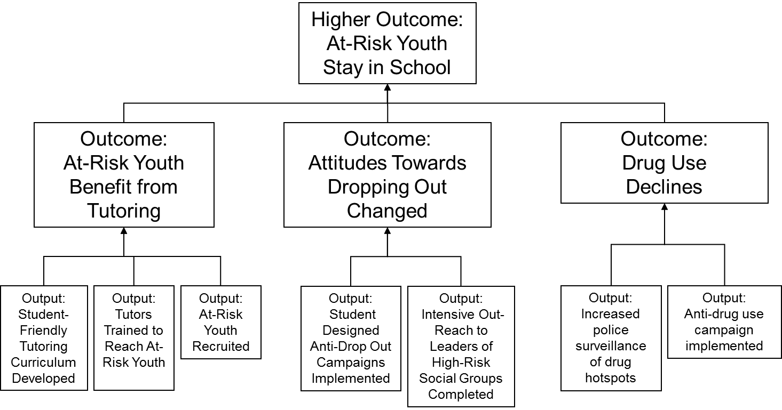

The graphic presentation of the results framework (the activity’s causality) should show a clear relationship among the levels of the objectives in the Results Framework. Indicators should be developed to measure progress toward the achievement of all objectives.
Looking at the results detailed in the chart, at each level is there logical consistency? Does each lower level result present both the necessary and sufficient actions and achievements to cause the achievement of the result at the next higher level (given appropriate assumptions)?
If the RF does not “make sense” then the corresponding indicators will not be useful or clear in regard to strategy and objective achievement.
Note: the results included at each level of the activity should be written in appropriate “results” language. USAID has developed useful guidance on the correct wording of the results statements included at each level of an RF in the Mission PMP. This guidance includes that the results statement should express an outcome as opposed to describing actions or processes; it should be clear and precise and stated in a way that can be objectively measured; and it should be uni-dimensional and only focus on one key discrete result.
At the lowest levels indicators may all be output or activity indicators (# of events) and as they ascend to higher levels the relative mix should change (not just # trained but % passing tests of learning) and, at the higher and highest levels, be all outcome or result indicators (% performing to standard, $ amount of sales, % change in income, sector growth rate, etc.).

ACTIVITies AND CONTEXT
Guidance: Provide clear and precise descriptions on the context, development hypothesis, project goal, purposes, objectives, geographic focus, as well as where or how this Activity contributes to the larger Project’s expected results. This section will also include the relevant sections of the Project’s Result Framework, with indications of components that are directly addressed by this Activity. It should also include the Activity RF.

ACTIVITY DESCRIPTION
Guidance: Include basic information about the project start date/end date, award amount, any contract mods, contract or agreement reference number, sub-contractors, etc. Note if this is an update to an existing M&E Plan and when the previous plan was approved. Insert text about how this activity contributes to the relevant DO. (This could either go in this section or in the “Activity Development Hypothesis” section.)
Sample text:
<Activity> is expected to contribute to USAID’s Development Objective #1: Broad-based, Inclusive Economic Development Accelerated.” In particular, it will contribute to IR1.1 “Private sector competitiveness increased.” Etc. Explain which result(s) from the DO Results Framework is equivalent to the activity/project purpose. [This could also be done graphically – see note under “Performance Indicators section.]

ACTIVITY LOCATION AND INSTITUTIONAL CONTEXT
Guidance Include information about Location, institutional context – local partners, relationship to Ministries, municipalities. Include a map if activities are carried out only in specified areas of Vietnam.

ACTIVITY DEVELOPMENT HYPOTHESIS OR THEORY OF CHANGE
Guidance: Provide clear and precise description on the activity’s theory of change, including how the activities are expected to contribute to the project’s higher-level purpose or goal. This description should outline the rationale of the project, i.e., explain its main development hypotheses.

ACTIVITY CRITICAL ASSUMPTIONS
Guidance: Explain relevant critical assumptions and “game changing” scenarios and assess risks associated with successful achievement of the Activity. A risk factor or critical assumption is something that lies beyond the implementing partner or USAID’s control. For example, the passage of a key policy reform may be required in order to sustain the delivery of certain programs, but this passage of this legislation is not within the direct manageable interest of the project.

USE
Guidance: Provide clear and precise descriptions of how data will be used to assess progress, document achievements and provide critical information for management decisions.)

RELATIONSHIP TO MISSION CDCS AND PMP

CONTRIBUTION TO USAID CDCS AND PMP
Guidance: This section should include a brief description how results contribute to the USAID Mission’s strategy (CDCS), and should indicate how M&E plan contributes to Mission’s PMP, and include a simple table that aligns project reporting indicators to USAID PMP indicators when the project reports directly against PMP indicators.
The activity and its intended results should be easily understood within the larger Mission PMP. Thus the activity (project) should be analyzed in the context of the relevant Mission Development Objective (DO), Intermediate Results (IRs) and Sub-IRs (where applicable) levels of the Mission PMP. This can be accomplished in a variety of ways including comparing objectives between the IP M&E plan and the Mission’s PMP, or from a direct mapping between the IR language and /or numbering system of the IP framework and the PMP.)
The table below is provided as a sample, but other formats may also be used.

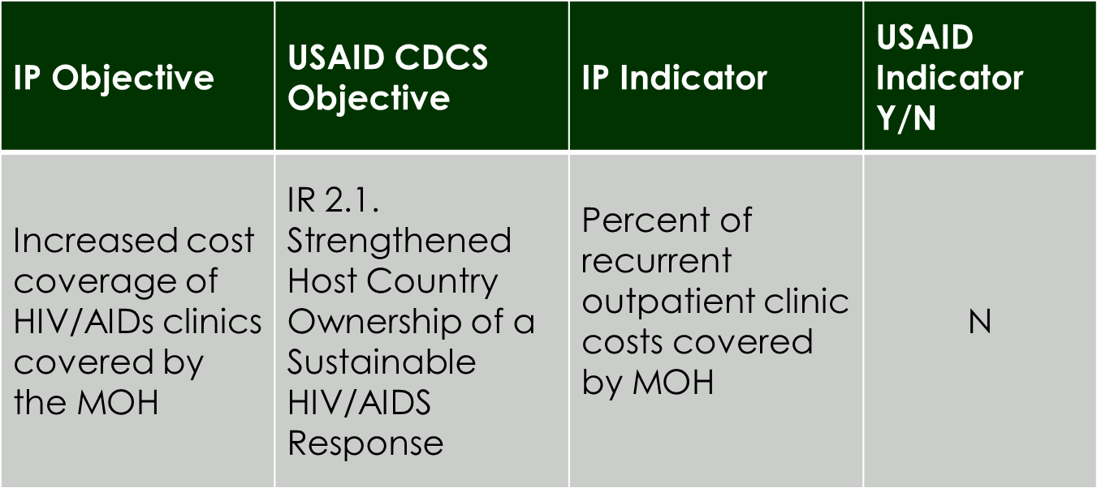

When the IP is working directly toward the achievement of a USAID objective it should be collecting data against one or more USAID program performance indicators. In instances when this occurs, the IP should be using the same indicator language, definitions and data collection methodologies as specified in the USAID PMP.

THE [ACTIVITY] PERFORMANCE INDICATORS
Required tables: 1) performance indicator table, and 2) Performance Reporting Table.
Guidance: Indicators are required for each of the project’s objectives/activities. USAID guidance suggests there should be no more than three indicators per activity – but the number of indicators should be sufficient to determine the achievement of the indicator. The specific indicator language is critical to ensure that the indicators – as currently worded – actually measure the results with which they are associated.
Each indicator should directly link to its result. An indicator should not measure multiple things (school buildings AND students), measure directions (“Increase” is a Result, “Number of” is an indicator), and must have a number (“good test results” or “better economic context” is not an indicator). Indicators should also be worded as specifically as possible using unambiguous terms (“achieved” is better than “addressed”).
Figure 2. Insert Performance Indicators Table here (or as an annex)
IR | Performance Indicators | Definition and Unit of measure | Data Source | Method or Tool | Frequency of Collection/Reporting | Use of Information
2.1 Strengthened Host Country Ownership of a Sustainable HIV/AIDS Response | Number of provinces implementing GVN core CoPC service packages | count | GVN-MoH | project form | Monthly/quarterly | for communication and decision-making

Performance indicators
Summarize the indicators for the activity’s work at each level. Indicators should be written in indicator language that is measurable and unambiguous and that follows USAID guidance for Validity, Integrity, Precision, Reliability, and Timeliness. Where indicators are reported “up” to the DO or Mission PMP levels they must have the same definition and collection and calculation methodologies as the higher-level indicators and also the same as those indicators of any other activity that contributes to these.

indicator BASELINES AND TARGETS
The AMEP should present Baselines and Targets for all indicators or, where these are still to be determined, the process for setting these and the timeline. Many will, in fact, be still TBD in the first version of the AMEP in the first 90 days but there should be none that are “blank” indicating that there is not yet a plan. It should be recognized that anything that the activity itself produces (trainings, meetings, etc.) will, by definition, be zero at the start. Note also that the process for setting the baseline for some indicators, particularly those that may be producing data needed for eventual impact evaluation, may involve surveys or intensive operations that may last for weeks or months and may involve procuring outside assistance.
Figure 3. Insert Performance Reporting Table here
IR | Performance Indicators | Baseline | Target  Year 1 | Target  Q1 | Target  Q2 | Target  Q3 | Target  Q4 | Target Justification
2.1 Strengthened Host Country Ownership of a Sustainable HIV/AIDS Response | Number of provinces implementing GVN core CoPC service packages | 0 | 10 | 1 | 2 | 3 | 4 | Reflects training schedule

CROSS-CUTTING ISSUES INCLUDING Gender AND SUSTAINABILITY
USAID has mandatory Gender Assessments when developing projects/activities. This guidance is evolving and the latest version from ADS, How-To Notes, or other official source should be consulted. Many mission CDCS and RFs have either a cross-cutting Gender DO or an explicit stand-alone Gender DO. The AMEP should be aware of this.
Activity should describe in what ways aspects of gender will be addressed in the M&E Plan. At a minimum, all indicators that could have gender aspects should be sex-disaggregated in their data collection, analysis, and reporting. This is, in the first instance, anything having to do with people involved in the activities as beneficiaries, farmers, owners, workers, students, trainees, heads of household, etc.
Where activities have issues or outcomes they are expecting to achieve related to specific gender groups (or other target groups), the indicators and expected results should clearly address this:
- # of new female business owners instead of # of new businesses owners disaggregated by sex
But, even where activities are not obviously directed at different groups, IPs should attempt to look deeper to examine if there could be disparate effects on different sexes as a result. For example:
- (May be obvious) Would improving availability of water change the lives of young girls more than young men? If so, how? And how measured?
- (Less obvious) Would a change in interest rates or fiscal policies affect the lives of women more than men? If so, how? And how measured?

Management of the Performance Monitoring system

ROLES AND responsibilities
Guidance: Provide clear and precise descriptions on the Activity’s M&E structures, functions, and capabilities, i.e. which staff/position(s) has what type/level of responsibilities for M&E at different implementation levels and their competencies. Ways to address issues identified should be provided, e.g. plan for staff M&E capacity strengthening, partnership with M&E organization(s) to strengthen the M&E system, etc.)
Sample text:
Implementing the M&E Plan
At the start of the project, the M&E Specialist will be the primary person responsible for implementing the M&E plan reported here. He/she will also responsible for building the capacity of all program staff, reporting and supervising general monitoring and evaluation approaches, practices, and tools. The M&E Specialist also cooperates with the MESP project on the technical level, ensuring that indicators and information are reported as needed by USAID and the AOR.
Information Management
With reference to ADS 203.3.3.1 g) [Name of Activity] supports the Mission’s efforts to maintain a performance monitoring information system that holds performance indicator including data collected by this Activity M&E plan. [A designated staff member] will regularly provide training-related information to TraiNet.
Reporting
The M&E Specialist is in charge of producing the M&E reports on time, and in a technically valid, high-quality, and policy-relevant manner, with the purpose of providing firm grounds for management decisions. He/she is responsible for developing the protocols and standard procedures to ensure that data is gathered in a technically sound manner, is consistent and can be compared throughout the years. He/she must make judgments with respect to whether or not data meets quality standards.
M&E Oversight
The Chief of Party (COP) will have responsibility for overseeing M&E, assuring that the work of the M&E Specialist meets overall project needs and responds to Mission requests for information. Missions in high-visibility locations such as Vietnam have frequent “data calls” and information requests, so assuring that our responses are policy- and decision-relevant is an important role.
Home Office Support
The [name of activity] receives technical support from the home office (HO) M&E staff. [Name of IM awardee] in Washington has assigned a long-term M&E expert to the project. His/her most essential services or responsibilities will be to ensure that high standards are maintained and activities are consistent with best practices in the field. From project start-up, the HO provides specialized assistance in finalizing the M&E Plan and offer specialized training to the M&E team, when needed.

Performance Reporting Schedule
Guidance: Provide a matrix (Gantt chart) indicating the planed tasks, frequency, timeline, responsible persons, etc., for performance monitoring. If the monitoring schedule is already included in the workplan, relevant information may be copied and pasted here from it.) Describe the various reports (with timing) that will be provided to USAID and what relevant M&E type content will be included in each. Include details of how USAID will receive indicator data (Quarterly PDT for example), evaluation data, DQA-type data and data from special studies, assessments and other non-indicator type data. Discuss relevant database systems for M&E data including databases, USAID’s TraiNet, etc. State that the project will cooperate with non-scheduled requests for specific M&E data updates.
Figure 3. Insert Gantt chart here
Sample text:
Activity will produce monthly and annual reports. Every third month – or quarterly – Activity will collate and update the performance data and review this with the COR. This will provide significant input to the quarterly update of the work plan schedule as activities planned for the following quarter in a general schedule are able to be scheduled more exactly.
Activity will provide quarterly Performance Summaries for the Mission. At the end of the fiscal year, the activity will submit an annual performance report including a compilation of the year’s actual achievement versus targeted for each indicator as well as explanatory narrative. All reports are presented in draft to the COR before final submission.

Evaluation Plan
Indicate planned evaluations and proposed schedule. To the extent possible the purpose of proposed evaluations should be articulated, as well as the relationship of required data to the proposed performance monitoring indicators.
A. Planned Evaluations and Schedule.
B. Purpose of Proposed Evaluations.
C. Link between Evaluations and Performance Monitoring Indicators/Data Collection.

ANNEX A: ACTIVITY PERFORMANCE Indicator Reference Sheet
Performance Indicator Reference Sheets (PIRS) should be completed for all indicators in the AMEP.

DATA SOURCES
Guidance: In terms of data sources, systems, procedures, tools, and collection methodology the M&E plan should describe how data quality will be assured as to:
VALIDITY: The data should clearly and adequately represent the intended result
INTEGRITY: The data should have safeguards to minimize the risk of transcription error or data manipulation
PRECISION: The data should have a sufficient level of detail to permit management decision-making
RELIABILITY: The data should reflect consistent collection processes and analysis methods over time
TIMELINESS: Data should be available at a useful frequency, be current, and timely enough to influence management decision-making.)

DATA COLLECTION METHODOLOGY
Guidance: This section describes in detail who is responsible for data collection and management (M&E manager, technical specialists, others), and in what format (database, spreadsheets, GIS) data will be managed, and who is responsible for producing which reports. Aspects of quality control at all stages should be described. Relevant details about types of data collection issues such as sampling, tool design, use of sub-contractors and project staff for data collection, etc. would go here. The specific methods used to collect data for the specified indicators are described in detail in each PIRS.
Figure 4: Performance Indicator Reference Sheet
Performance Indicator Reference Sheet
Name of Activity Development Objective (or Goal or Purpose):
Name of Activity Intermediate Result:
Name of Activity Sub-Intermediate Result:
Name of Indicator:
Indicator Type: Activity Custom______ F_____ Mission PMP ______
Is this a PPR indicator? No____ Yes ____, for Reporting Year (s) ______________________
DESCRIPTION
USAID Definition (if applicable):
Precise Definition(s):
Unit of Measure:
Method of calculation:
Disaggregated by:
Justification & Management Utility:
PLAN FOR DATA ACQUISITION
Data Collection Method:
Data Source(s):
Method of transfer to USAID:
Frequency & Timing of Data Acquisition:
Estimated Cost of Data Acquisition:
Individual Responsible at IP (title):
Individual Responsible for providing data to USAID:
Location of data storage:
DATA QUALITY ISSUES
Date of Initial Data Quality Assessment:
Known Data Limitations and Significance (if any):
Actions Taken or Planned to Address Data Limitations:
Date of Future Data Quality Assessments:
Procedures for Future Data Quality Assessments:
PLAN FOR DATA ANALYSIS, REVIEW, & REPORTING
Data Analysis:
Presentation of Data:
Review of Data:
Reporting of Data:
OTHER NOTES
Notes on Baselines/Targets:
Other Notes:
PERFORMANCE INDICATOR VALUES
Year | Baseline | Target | Actual | Notes
2015
2016
2017
THIS SHEET LAST UPDATED ON: / /

Annex b: DATA QUALITY ASSESSMENT FORM
Note: it is the responsibility of USAID AORs/CORs to ensure data quality assessments for all projects are conducted as required. The general rule is that USAID must conduct a formal DQA for all indicators that are reported to USAID/Washington and this must be done every three years. However, IPs should also have quality procedures in place to ensure that performance reporting data meets DQA standard criteria. If the IP is receiving data from a grantee or subcontractor, the IP must also ensure that their partners meet these standards.
The Data Quality checklist form is provided on the following pages.

Data Quality Checklist
Project/Activity Name:

Title of Performance Indicator:
[Indicator should be copied directly from the Performance Indicator Reference Sheet]
Linkage to Foreign Assistance Standardized Program Structure, if applicable (i.e. Program Area, Element, etc.):

Result This Indicator Measures (i.e., Specify the Development Objective, Intermediate Result, or Project Purpose, etc.):

Data Source(s):
[Information can be copied directly from the Performance Indicator Reference Sheet]
Period for Which the Data Are Being Reported:

Is This Indicator a Standard or Custom Indicator? | ____ Standard Foreign Assistance Indicator  ____ Custom (created by the OU; not standard)
Is this indicator a required USAID indicator? | ____ Y  ____ N
Data Quality Assessment methodology:
[Describe here or attach to this checklist the methods and procedures for assessing the quality of the indicator data. E.g. Reviewing data collection procedures and documentation, interviewing those responsible for data analysis, checking a sample of the data for errors, etc.]

Date(s) of Assessment:
Assessment conducted by:

Category | Y | N | Not Applicable/ Insufficient information | Comments
Validity
Does the indicator reflect the intended results of the activity – i.e. is it a useful indicator for activity management?
Do the data being collected and reported match the intent or language of the indicator?
Are the data collection methods (interviews, observation, etc.) appropriate to produce good data?
Are the data collection procedures and/or sources relatively free of bias?
Are the people collecting the data qualified and/or adequately experienced?
Are the people collecting the data properly supervised?
Reliability
Are the definitions and procedures for data collection, calculation and reporting clear and well understood by all relevant staff?
Do the definitions and procedures for collecting and calculating the data match the Mission PIRS if applicable?
If not, please describe the differences.
Are data collection and analysis methods documented in writing in a PIRS or another form?
Is a consistent data collection process used from (describe any changes/differences observed if N):
Year to year?
In all activity locations/sites?
By all activity partners/sub-contractors?
Are there procedures in place for periodic review of data collection, maintenance, and processing that can detect data quality issues?
Has the partner identified significant data quality limitations in the past?
Were these communicated to USAID? If yes, describe how.
Have these data quality limitations been addressed by the partner? If yes, explain how.
Has the partner identified significant data quality limitations in current data? If yes, please describe.
Are these limitations described in the indicator PIRS or written data collection and analysis procedures? If yes, please describe.
Are these limitations described in reporting to USAID? If yes, please describe.
Timeliness
Are the data for this indicator reported to USAID by the method (ex. Quarterly Performance Data Table) and frequency required?
Is this format and schedule appropriate for project/activity management? If no, describe how it should be changed,
Precision
Is there a method for detecting duplicate data? If yes, please describe.
If there is duplication of data, is the level of duplication acceptable for this indicator? Describe why or why not.
If there is unacceptable duplication of data, is it identified in the PIRS under data limitations or another section?
If there is unacceptable duplication of data, has information on duplication been shared with USAID? Describe how.
Is there a method for detecting missing data? If yes, please describe.
If there are missing data, is the level acceptable for this indicator? Describe why or why not.
If there are unacceptable amounts of missing data, is this identified in the PIRS under data limitations or another section?
If there are unacceptable amounts of missing data, has information on missing data been shared with USAID? Describe how.
Are the reported data disaggregated according to USAID guidance?
Integrity
Are there procedures in place to check for transcription errors at all levels of the data collection and reporting system?
Are there proper safeguards in place to prevent unauthorized changes to the data?
Are there procedures in place to ensure unbiased analysis of data and subsequent reporting?
Are their safeguards in place to ensure that all relevant tools, tracking sheets and data are backed up and protected from data loss?

IF NO DATA ARE AVAILABLE FOR THE INDICATOR | COMMENTS
If no recent relevant data are available for this indicator, why not?
What concrete actions are now being taken to collect and report these data as soon as possible or on schedule?
When will data be reported?

SUMMARY (where multiple items are listed by the assessor in each row, they should be numbered so that it is clear what recommendations apply to which limitations)
Based on the assessment above, what is the overall conclusion regarding the quality of the data?
What limitations, if any, were observed and what actions should be taken to address these limitations?

Final agreed upon actions and timeframe needed to address limitations prior to the next DQA:

Annex C: Data COLLECTION tools
Add as an annex any forms used to collect data; data vetting procedures, survey questionnaires used, sample design information.

