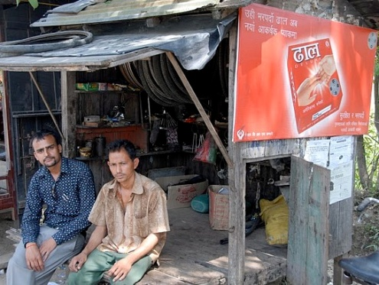Health and Family Planning Program  
Ghar Ghar Maa Swasthya (Healthy Homes) Project

Peter Oyloe/FHI 360

USAID/Nepal’s Ghar Ghar Maa Swasthya (Healthy Homes) project will work with the Nepal Contraceptive Retail Sales (CRS) company to increase the accessibility and availability of family planning and public health products throughout Nepal, especially in hard-to-reach rural areas.   
  
The Government of Nepal (GON) endorses social marketing (i.e., use of commercial marketing principles and techniques to increase the accesibility and availability of quality, subsidized health products, especially in underserved areas), as an approach to addressing unmet demand for essential public health products and services and influencing a target audience to voluntarily change behavior for the benefit of the individual and society as a whole. USAID’s *Ghar Ghar Maa Swasthya*, or Healthy Homes project, complements GON efforts to expand the depth, reach, and impact of the private sector in social marketing and provide affordable, high-quality maternal and child health, family planning, and HIV prevention products and services.

**SNAPSHOT**

**Life of Project:** 2010 to 2015

**Goal:** Establish the Nepal CRS Company as a profitable corporate leader in health products and increase the accessibility and availability of these products throughout Nepal, especially in hard-to-reach rural areas

**Implementing Partners:** Nepal CRS Company and Family Health International

**Geographic Focus:** National focus

*A bicycle repair shop sells USAID-donated condoms on the east-west highway along the Terai districts of Nepal.*

USAID/Nepal’s work in social marketing began in 1978 with the establishment of the Nepal CRS Company, one of the oldest and most successful social marketing organizations in the world. CRS quickly established itself as a pioneer in health communications and marketing and played a key role in developing markets in Nepal for: condoms as a family planning and HIV/AIDS prevention product; contraceptives like oral pills, injectable Depo-Provera, intra-uterine contraceptive devices and implants; and maternal and child health products like oral rehydration salts, clean delivery kits, and water purification liquid.   
  
With these important accomplishments, CRS is now relying more on its own resources and slowly decreasing its dependency on donor funding to support its operations and activities. Still, Nepal’s hilly and mountainous landscape, without proper roads, makes the marketing and distribution of public health products in those areas challenging. Despite these challenges, CRS has been very successful in making its products available in all 75 districts of Nepal, especially in the hard-to-reach areas of the country.

PROGRAM OVERVIEW

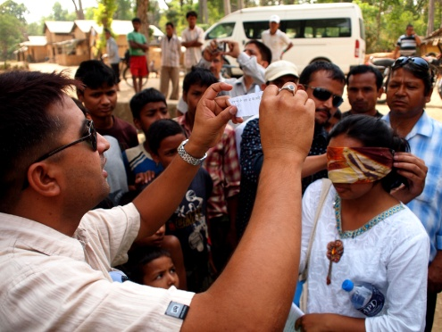Ghar Ghar Maa Swasthya consists of two components. Under the first component, USAID funds CRS to efficiently expand access to quality, affordable health care underserved communities. This component focuses on increasing CRS’s institutional sustainability through commercial “for profit” marketing in the urban areas with higher disposable income and the promotion and sales of subsidized products in the hard-to-reach, low-income areas. Under the second component, USAID assists CRS to strengthen its organizational systems, develop and implement strategic business plans, and design and implement stronger behavior change communication activities, such as generic campaigns that promote best practices in public health, in order to influence voluntary behaviors that improve both personal and soceital welfare.

Subel Bhandari, Photojournalist

*Nepal Contraceptive Retail Sales Company, USAID's prime social marketing partner, uses “infotainment” games to increase correct and consistent use of condoms among those most-at-risk for contracting HIV*

pROGRAM AcTIVITIES and planned results

GGMS builds on the successes of previous USAID-funded projects and contributes to increasing and improving Nepal’s modern contraceptive prevalence rate, reducing the mortality rate among mothers and children under the age of five (including newborns), and reducing the incidence of HIV/AIDS. Specific GGMS results and activities include the following:

* **Increasing CRS’s Independence and Sustainability**: Increasing the sale of health commodities in existing markets and entering new markets, covering both urban and rural communities, to strengthen CRS’s revenue generation, and reinvesting the money into new product development and sales to further boost the company’s institutional sustainability.

**CONTACT**

U.S. Agency for International Development

G.P.O. Box 295

Brahma Cottage, Maharajgunj

Kathmandu, Nepal

Tel: 977-1-4007200

Fax: 977-1-4007285

Email: [usaidnepal@usaid.gov](mailto:usaidnepal@usaid.gov)

Web: [www.usaid.gov/nepal](http://www.usaid.gov/nepal)

[www.facebook.com/usaidnepal](http://www.facebook.com/usaidnepal)

[www.twitter.com/usaidnepal](http://www.twitter.com/usaidnepal)

**Nepal CRS Company**GPO Box # 842  
Tokha Road, Mahadev Taar, Gongabu,

Kathmandu, Nepal  
Tel: 977-1-4362097

Email: [mis@crs.org.np](mailto:mis@crs.org.np)

Web: <http://www.crs.org.np>

**Family Health International**

GPO Box #21249

Anamika Galli, Baluwatar

Kathmandu, Nepal

Tel: 977-1-4444753

Fax: 977-1-4411662

Email: [ggms@fhi360.org](mailto:ggms@fhi360.org)

Web: <http://www.fhi360.org>

* **Focusing on Rural, Hard-to-Reach Areas**: Enhance access to underserved and most-at-risk populations by extending CRS’s distribution network deeper into hard-to reach areas, engaging NGOs, and expanding promising community-based marketing initiatives.
* **Building CRS’s Leadership Capacity**: Continue to support CRS, Nepal’s oldest and one of the most successful social marketing organizations in the world, in management systems, leadership development, business planning and administration to emerge as a leading, self-reliant company for quality health products and services.
* **Implementing Cutting-edge, Strategic, Voluntary Behavior Change Communication**: Support implementation of innovative, evidence-based voluntary behavior change communication activities to raise public awareness and promote positive behaviors and norms around pregnancy, childcare, and HIV prevention, among other important public health issues. FHI 360 also designs and implements generic strategic behavior change communication programs for key health and family planning issues as identified by USAID.