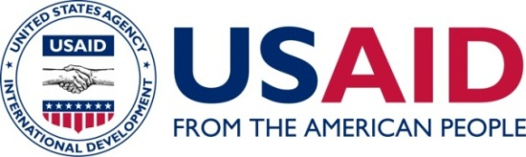

mHEALTH IN WEST AFRICA: A LANDSCAPE REPORT

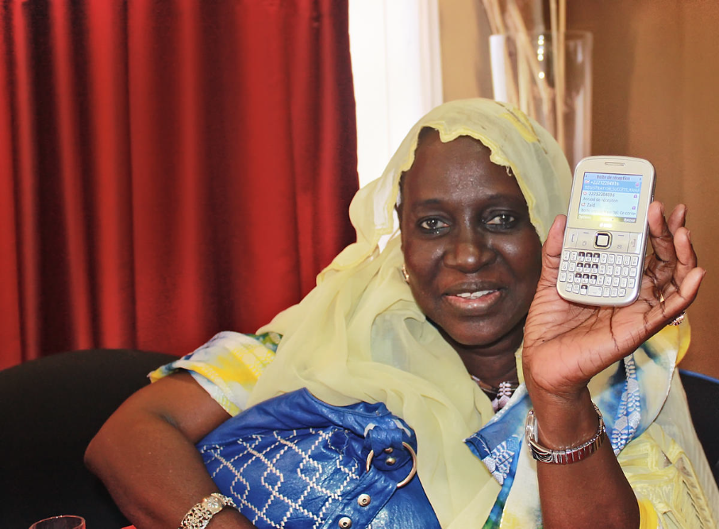
A health worker in Mauritania shows the SMS which indicates that she has correctly sent her nutrition report © 2012 eHealth Africa, Courtesy of Photoshare

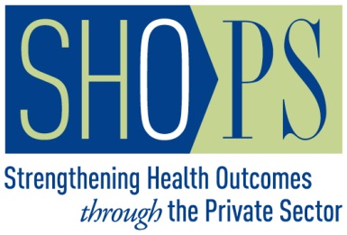
May 2014

This publication was produced for review by the United States Agency for International Development. It was prepared by Pamela Riley for the Strengthening Health Outcomes through the Private Sector (SHOPS) project. The views expressed in this material do not necessarily reflect the views of USAID or the United States government.

Executive Summary

BACKGROUND

Many of the sub-Saharan Africa mhealth activities featured in various mhealth compendiums, databases, conferences, and high-visibility partnerships are located in the eastern and southern African countries. Less information has been available about mhealth opportunities and barriers in West Africa. The United States Agency for International Development West Africa Regional Health Office (USAID/WA) commissioned the Strengthening Health Outcomes through the Private Sector (SHOPS) project to conduct a landscape analysis of mhealth in West Africa with two objectives: (1) to assess current applications, stakeholders, trends, and barriers in the use of mobile technologies to improve health outcomes (mhealth) in the West Africa region; and (2) to identify promising mhealth public-private partnerships (PPPs) for its two flagship projects addressing regional program needs in HIV (Prévention et prise en charge du VIH/SIDA en Afrique de l’ouest or PACTE VIH) and family planning (FP) (Agir pour la planification familiale or AGIR PF).
This report provides an overview of mhealth activity in the West Africa region, including the 15 Economic Community of West African States (ECOWAS) countries and two additional focus countries for USAID’s West Africa Mission: Benin, Burkina Faso, Cameroon, Cape Verde, Cote d’Ivoire, Gambia, Ghana, Guinea, Guinea Bissau, Liberia, Mali, Mauritania, Niger, Nigeria, Senegal, Sierra Leone, and Togo. Of particular interest to USAID/WA are opportunities for its two flagship projects, Agir pour la Planification Familiale (AGIR-PF), which seeks to expand access to and use of FP services in urban and peri-urban areas of selected cities, and Prévention et prise en charge du VIH/SIDA en Afrique de l’ouest (PACTE-VIH) which seeks to improve quality of and access to HIV services for key populations.
mHealth is the use of mobile technology to improve health outcomes. The term “mhealth” encompasses a broad range of applications supporting both supply side and demand side health activities. For the purposes of this report, these categories were further grouped into services targeting beneficiaries, services targeting health workers, and services used by health program managers. mHealth is a subset of a broader category of services known as ehealth, which encompasses any transfer of health resources electronically including computer systems, databases, and internet access and dissemination.
mHealth matters to HIV/AIDS and SRH/FP programs because mobile networks and phone ownership have penetrated communities underserved by health services; this provides access to underserved populations. mHealth tools offer solutions to long-standing HIV/AIDS and SRH/FP program challenges by including more consistent and cost-effective data collection, engagement with beneficiaries often lost to follow-up, and support for overburdened health workers. Partnerships matter to mhealth because sustainable large-scale interventions require resources from a cross-sector of stakeholders such as public health officials, telecommunications companies, application developers, researchers, and community organizations. Effective mhealth partnerships are critical to effective health outcomes.
METHODOLOGY

The assessment featured in this report was a simple cross-sectional design with data collected through a combination of key informant interviews (in person and by phone) as well as a desk review conducted between November 2013 and April 2014. Government officials, mhealth implementers, software companies, mobile operators, donors, USAID Mission staff, and global mhealth experts contributed their insights and experiences.

FINDINGS
West Africa Mobile Industry
The West Africa mobile industry is highly competitive, with at least two private providers in each country, and an average penetration of 69% across the region. Mobile subscriptions are growing at a rate of 18% per year. Low-end phones dominate with limited penetration of smart phones and tablets, especially outside urban areas. As shown in the table below, mobile penetration varies from 29% in Niger to 120% in Gambia. STOP

Figure 1: Mobile Penetration and Internet Use
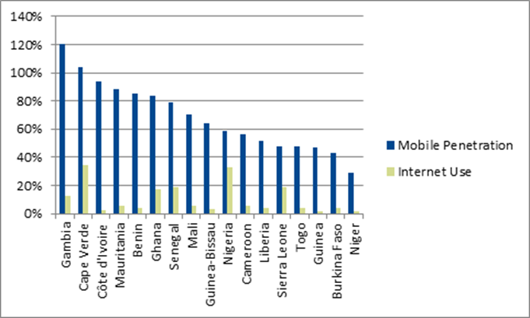

Five mobile operators have significant presence in the region with licenses in at least four countries. This provides opportunities for partnerships that span across national borders.

Figure 2: Five Mobile Operators with Significant Regional Presence

West Africa mHealth
The 17 West Africa countries reviewed for this report represent varying levels of mhealth investment and experience, with most being at a very nascent stage of activity.

Figure 3: Level of mHealth Investment and Experience

NASCENT
MODERATE
ACTIVE
Level of mHealth Activity | Category Description
ACTIVE | High number and breadth of planned and current interventions, large presence of mobile value-added service companies, emergence of iHubs and mLabs, larger scale private sector initiatives, multi-sector initiatives
MODERATE | Recent momentum in mhealth applications, a growing variety of interventions including research trials, private sector interest, growth in information and communication technology (ICT) incubators and training opportunities
NASCENT | Lower number of pilots and partners in development; generally limited presence of application software developers, electric supply/charging stations erratic

Limitations, barriers, and gaps
- Even in the most active countries, most interventions are small-scale and donor-funded with no financial model for long-term sustainability or sense of real country ownership.
- Mobile operator partnerships are funded primarily through foundations or corporate social responsibility grants without integration in business units.
- mHealth evidence is lacking, especially around cost and cost effectiveness.
“Our country received Global Fund monies to develop a mobile platform to connect regional directors for organizing HIV response. Once the funding ended, the system is not used.” MOH staff, Burkina Faso, March 2014
- MOH stakeholders support mhealth initiatives but lack resources and capacity to coordinate and finance.
“We must rely on government partners to fund the training of their workers in tools we develop, but often there are no resources to do this.” Orange interview, November 2013

- Countries may have mhealth or ehealth strategies, but many draft plans have not been validated or operationalized. Enabling policies are needed in some cases to address barriers such as policies prohibiting any unsolicited SMS.
- Gaps in signal coverage are a problem in many areas and cause frustration with technology projects.
“Our agents became frustrated in Bamako when network dropped messages and data was lost.” Pesinet interview, March 2014

Why has mhealth lagged in West Africa?
Compared to other regions in sub-Sarahan Africa, especially South Africa and the East African countries of Kenya, Tanzania, Uganda and Rwanda, the West Africa region is less active. Informants suggested the following reasons for this situation:
- East Africa’s early success fuels its continuing dominance. Once a regional presence was established in the mid-2000s through the creation of mobile innovation labs, mhealth developers saw East Africa as a lower-risk, lower-cost foothold to find ICT talent, pilot innovations, and bring new applications to scale. East Africa’s technology sector was also greatly boosted by investments in fiber optic cable along Eastern Africa corridor.
- mHealth remains an English-centric community, creating barriers for francophone Africa. There are hundreds of mhealth websites, databases, newsletters, journals, message mboard, training manuals, listservs, and application manuals available only in English. Only a portion of which have been translated.
“Our organization needed a critical mass of partners in West Africa in order to justify the costs of translating CommCare application, instructions, and web support into French.” Dimagi field manager, West Africa, Nov 2013

- Many barriers to mhealth adoption are not unique to West Africa, but reflect economic burdens of the region. Literacy barriers, including ICT literacy, are high. With limited evidence of mhealth impact in developing countries, governments are cautious about investing limited health funds.

Four regional trends providing momentum for mhealth in West Africa
WAHO’s leadership in ehealth: Through WAHO’s ehealth strategy and support for harmonized health information platforms and standards such as District Health Information Software 2 and open source human resources information solutions, ministries are building greater capacity to drive mhealth activities linked to broader heath system needs.
Growth in common platforms: As the mhealth field has matured, the community has begun to coalesce around integrated platforms that support many functions and applications. Examples include ChildCount+, CommCare, Magpi (previously Episurveyor), DataWinners, and MOTECH. Many of the initiatives identified in West Africa use similar software which can lead to economies of scale and more rapid knowledge transfer.
Growth in French language resources: There are a growing number of NGOs devoted to increasing the capacity of organizations in francophone countries to use information and communications technologies for development objectives. These organizations are developing training manuals, tools, and message content in French for mhealth initiatives.
Escalation of mhealth in Nigeria: As the region’s economic center, Nigeria has recently attracted significant global investment with potential to impact the greater ECOWAS community. Examples include the ICT4-SOML partnership and the GSMA Pan African mHealth Initiative.

Selected mhealth initiatives in West Africa
The SHOPS team identified more than 100 mhealth interventions across the 17 countries, including multiple initiatives in the countries identified as nascent. The activities were grouped into four categories of applications with the most relevance to HIV and FP programs.
Mobile money: Mobile money services have been authorized throughout the West Africa region and provide promising partnership opportunities for health partners and mobile operators. The integration of financial and health services offers potential revenue streams to fund health information and may greatly improve the reach of health insurance for the informal sector.
Data collection: Program management applications are the most common mhealth use cases, including registries and vital events tracking, electronic medical records, disease surveillance, data collection and analysis, and supply tracking systems to reduce stockouts. These applications improve coordination of national, regional, and local stakeholders through shared access to a common database, and can lower costs and increase quality of data collection for more timely analysis and decision-making.
Consumer applications: mHealth interventions are frequently used for community mobilization, awareness raising, education, and demand creation. Most of the mhealth applications currently being implemented are standalone interventions that send SMS messages or offer a hotline into which clients can call with questions. The anonymity of mobile messages are particularly valued by stigmatized populations.
Health worker support: Health care provider tools have been developed to improve efficiency and quality of care, including point-of-care decision support, remote consultation and supervision, peer support groups, case management software, job aids, and other training resources. Mobile tools enable health workers to see more clients by reducing time for case management and reporting, and improving quality of counseling and diagnostic skills.

ConCLUSion

For maximum impact, mhealth initiatives require national leadership, donor coordination, and well-designed partnerships that provide benefits to all participants. Wise implementation of mhealth strategies and investment in regional partnerships can result in stronger HIV and FP programs, with greater reach, lower cost, and higher quality.
USAID West Africa has a window of opportunity to work with WAHO, regional institutions and other donors to catalyze change in the current mhealth implementation landscape. To harness the potential of mobile technologies, WAHO guidance is needed to help countries set the vision, manage the process, develop and operationalize plans, provide tools for developing ICT capacity, and ensure platforms align around national standards and health priorities. The trends, gaps and opportunities highlighted in this report are intended to provide a starting point for such actions.

RECOMMENDATIONS

Effective partnerships are critical to designing and financing effective and durable mhealth interventions. WAHO’s leadership is essential to creating a forum and framework for national governments to drive these partnership efforts. If country ownership is absent, mhealth projects will remain tangential to broader health system reforms. Through WAHO, MOHs and their partners can come together to address common needs regarding ICT capacity-building tools, and agree on key indicators and standards around which to develop solutions. In partnership with WAHO, USAID missions or projects can act as “neutral brokers” to facilitate dialogue between industry, government, and civil society organizations for mhealth activities.

Pathways to partnerships
“We are interested in partnerships with mobile operators and mhealth developers; how do we get started?”
MOH staff, Senegal
PACTE-VIH and AGIR-PF are familiar with the mhealth applications described in this report, and they are actively planning and piloting uses of mobile technology. These include pilots to target beneficiaries with mobile awareness messages and educational content, use SMS for commodity tracking and reporting increase awareness, and assist providers with client follow-up. For these efforts to achieve impact at scale, cross-sector partnerships will be needed to develop, grow, and sustain these solutions.
mHealth experts and stakeholders in the West Africa region emphasized three pathways or critical steps to developing effective partnerships.

- Create a national mhealth technical working group: Convening mhealth stakeholders in a structured forum serves to establish leadership, organize partners, identify areas of duplication and collaboration, align investments with national health priorities, and energize activities. USAID projects can serve as neutral brokers to convene and host under the leadership of health ministries. Working in partnership with WAHO, USAID W/A can support the development of technical working groups by providing opportunities for sharing processes and progress of national activities.
- Work with mobile regulatory authorities to explore funding options for large-scale public health initiatives: Mobile operators pay high levels of taxes and fees, including contributions to universal service funds designed to subsidize services in geographic regions where there is no market incentive to do so. Under the leadership of MOHs, USAID partners could work with government regulators to develop incentives for operators to subsidize mhealth charges in exchange for universal service fund distributions or other tax incentives.
- Make use of global mhealth resources and guides: There is a growing body of mhealth best practices, websites, and webinars to guide the development of effective solutions and partnerships. One example is mHelp, a new initiative led by the mHealth Alliance. It connects stakeholders with qualified local consultants who can provide assistance across technical areas from mhealth training to working with mobile operators.
Partnership opportunities
Mobile operators are involved in many mhealth pilots and interventions documented in this report, funded primarily through foundations or corporate social responsibility grants. The recommendations below are designed to create mhealth partnerships with greater potential for scale by providing clear contributions from and benefits to all partners. WAHO, USAID West Africa and other regional institutions can help guide partner negotiations by identifying public and development sector contributions, bringing in other program partners to aggregate demand and drive scale, and developing shared metrics. The specific companies and organizations highlighted are illustrative; USAID implementating partners, under guidance of MOHs, could issue RFPs to identify interested operators.
- Develop a strategic partnership with a regional mobile operator: Under the leadership of WAHO and MOHs, USAID projects should aggregate their use cases and develop a partnership with one or more operators to create optimum commitment and incentives for investment and learning. Orange Mobile (licensed in Cote d’Ivoire, Mali, Senegal, Niger, Guinea, and Guinea Bissau) has expressed interest in a partnership that crosses national boundaries. It seeks to explore how it could leverage its assets—such as mobile application design, software development, tech support, billing solutions, marketing and distribution, and channels for delivering SMS, voice, and data messages —in a strategic partnership. Health partners could contribute complementary assets—such as convening local stakeholders, assessing end user needs, training, government capacity building, stakeholder outreach, monitoring and evaluation, and knowledge dissemination—to ensure a partnership is mutual and sustainable.
- Initiate a partnership focused on mobile money opportunities: Mobile money services have potential to subsidize mhealth content as a bundled service, and mobile money providers are seeking partners which access those in need of financial services such as savings, credit, and insurance. Etisalat WEENA program (Cote d’Ivoire, Togo, Benin, and soon Niger) provides micro-loans to rural female entrepreneurs and is seeking expansion partners with opportunities for marketing health information or products.
- Negotiate closed user group agreements: Closed user groups are common “calling plans” that can reduce costs for communications among group members such as health professionals or beneficiaries within a network. USAID partners could work with Switchboard, an NGO that has pioneered agreements in Ghana, Liberia, and Tanzania and demonstrates how mobile operators can realize financial returns from providing free calls for in-network calls while charging retail prices for calls to friends and family members.
- Support the development of a regional digital health education platform in French: To promote knowledge-sharing objectives, USAID/WA could catalyze funding for a shared mobile-accessible information repository on sexual and reproductive health. Under WAHO leadership, MOHs would provide oversight for local adaptation and final content approval. One model is the My Question My Answer database developed by OneWorld UK, a nonprofit organization with a regional presence. A single regional hub shared among a broad array of partners would lower per-user costs of content development, training, monitoring, marketing, and mobile operator negotiations.

