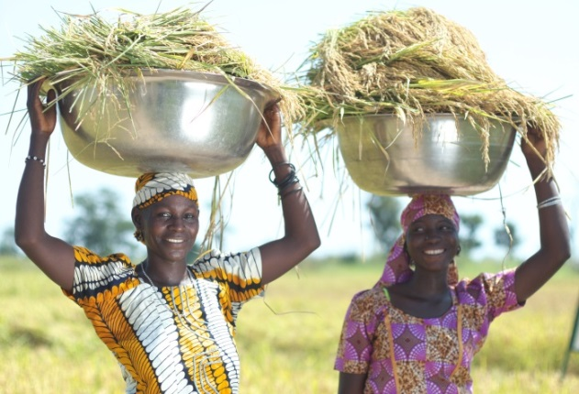
USAID’s flagship agricultural project in Nigeria is under the U.S. Government's Global Hunger and Food Security Initiative, also known as Feed the Future.
In Nigeria, USAID's agriculture project focuses on small-scale farmers, known as smallholders. USAID builds their skills to increase their incomes; improve productivity and nutrition; and provide food security for Nigeria’s rural poor through innovative approaches. Smallholder farmers are trained to use techniques that will increase access to improved seeds and optimal use of fertilizer, adequate finance, better water management, appropriate technology, extension services, and improved nutritional use of grown or purchased food. The project uses proven private sector demand-driven market interventions, and focuses on constraints in the agricultural value chain.
QUICK FACTS:
Implementing partner: Chemonics International
Timeframe: FY April 2012 – FY April 2017

Other partners:
- Foundation for Partnership Initiatives in the Niger Delta (PIND)
- International Fertilizer Development Centre (IFDC)
- International Fund for Agricultural Development (IFAD)
- Syngenta and other private sector agribusinesses
- Federal Ministry of Agriculture and Rural Development (FMARD) and States’ Ministries of Agriculture and ADPs
- World Bank-GoN FADAMA III project

Amina and Fatima are members of Batagi Munchita Bayijinre Women Cooperative Multi-purpose Society in Niger state. They both agree that they are “more ready to face their future with confidence”.

USAID invests $60.5 million in activities in support of smallholder farmers with between one to five hectares of land. The project works along the value chain through producer associations, credit organizations, agribusinesses such as suppliers, contractors, transporters, agro-processors, and state and federal public institutions to identify and alleviate constraints to well-functioning markets.
USAID identifies and supports agricultural opportunities along the value chain, such as farming services and micro and small scale processing, to ensure inclusion of women and youth in the rural economy. USAID works with 700,000 smallholder farms in aquaculture, cassava, cocoa, maize, rice, sorghum, and soybean production.

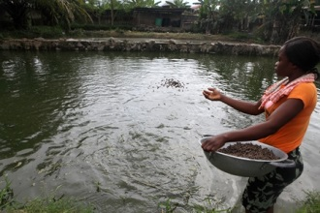
A young woman feeds catfish Ondo state
PROJECT GOAL
Increased smallholder income from agricultural development promoted through enhanced private sector participation and investment.

PROJECT OBJECTIVES
- Improve agricultural productivity
- Increase income and resilience of vulnerable communities and households
- Expand markets and trade
- Increase private sector investment in agriculture and nutrition-related activities
- Increase small scale commercial farming
- Improve access to diverse and quality food
- Increase the involvement of women and youth

BY THE NUMBERS (As of Q1 FY2015)

614,309 | Rural households received agricultural and food security assistance

130 | Public-private partnerships facilitated

$129 million | Rural & agricultural loans facilitated

334,151 | Farmers adopted new technologies and management practices

31,570 | Vulnerable household benefitted
CONTACT INFORMATIOn
Mission Director
Michael Harvey
U.S. Embassy
No. 1075 Diplomatic Drive
Central Area, Abuja
Nigeria
P.M.B. 519 Garki, Abuja
Tel: 234-09-461-9400

Desk Officers
Chad Weinberg
Tel: +1 202-712-0511
Email: cweinberg@usaid.gov
Julie Fitzgerald
Tel: +1 202-712-1422
Email: jfitzgerald@usaid.gov

