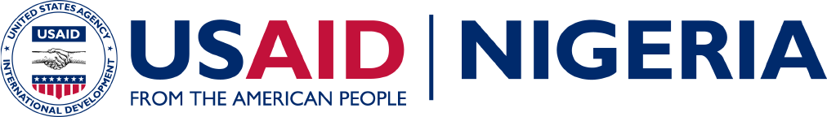

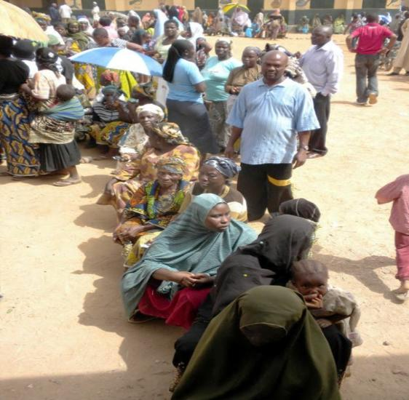
There are many roadblocks to building a strong democracy in Nigeria. Conflict -- triggered by political and communal competition, ethnic, religious, or resource allocation rivalries -- poses a major threat to democracy. Corruption is a key problem that pervades the daily lives of Nigerians. Civil society lacks both the capacity and the resources to effectively engage with government and advocate for change.

On the bright side, Nigeria experienced noteworthy democratic successes in 2011, including one of the most free, fair and credible elections in the country’s history. Also, recent legislative progress includes the passing of the federal Freedom of Information (FOI) Act. For the first time, public institutions are legally required to keep proper records and are obliged to respond to requests for information within seven days. Another positive development includes the passage of the Public Procurement and Fiscal Responsibility Bills by the Sokoto State House of Assembly in 2012.
Women waiting to cast their votes - Abuja, FCT, 2011

USAID supports credible election, and efforts to deter corruption, mitigate conflict, promote accountability, and ensure efficient delivery of services. Programs support civil society organizations’ advocacy campaigns for key policy reforms at the national, state and local levels, build partnerships between civil society coalitions and the media, reform-minded government institutions and the private sector.
Budget 2012-2014:
2012: $ 8 million
2013: $ 12 million
2014 (est.): $ 32 million
USAID sponsored peace-club meeting in a Kaduna Secondary School.
Photo by:

USAID sponsored peace-club meeting in a Kaduna Secondary School.
Photo by:

USAID assistance builds the capacity of local and state government officials to assume greater responsibilities and address demands and expectations of their constituents. USAID is an active participant in donor coordination and in efforts to promote progress in Nigeria’s transition to multi-party democracy.
results:
- Increased capacity for civic advocacy, monitoring and engagement
- Enhanced credibility of election results
- Created responsive governance at State and local levels
- Mitigated conflict among at-risk communities

Good Governance
USAID engages state and local governments, as well as civil society and private sector stakeholders to improve governance. USAID builds the capacity of key government agencies to plan, budget, track, manage and evaluate their fiscal and administrative responsibilities; reinforces policies and systems that improve transparency; mobilizes civil society and the private sector to participate in community planning and budgeting, monitor financial flows and assess the quality of services.
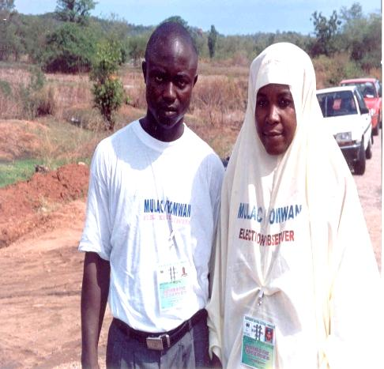
Political Competition and Consensus Building
Nigeria has struggled to consolidate its young democracy since its return to civilian rule in 1999. The general election in April 2011 was an improvement in credibility and transparency. Ahead of the 2015 elections, USAID will support the organizational development of political parties, the independence of the electoral commission, and increase civil societies’ input into the electoral and constitutional reform dialogue. USAID supported interventions will also contribute to the sustainability of Nigeria’s institutions and wide participation of the electorate.
Election observers during the 2011 elections - Abuja FCT

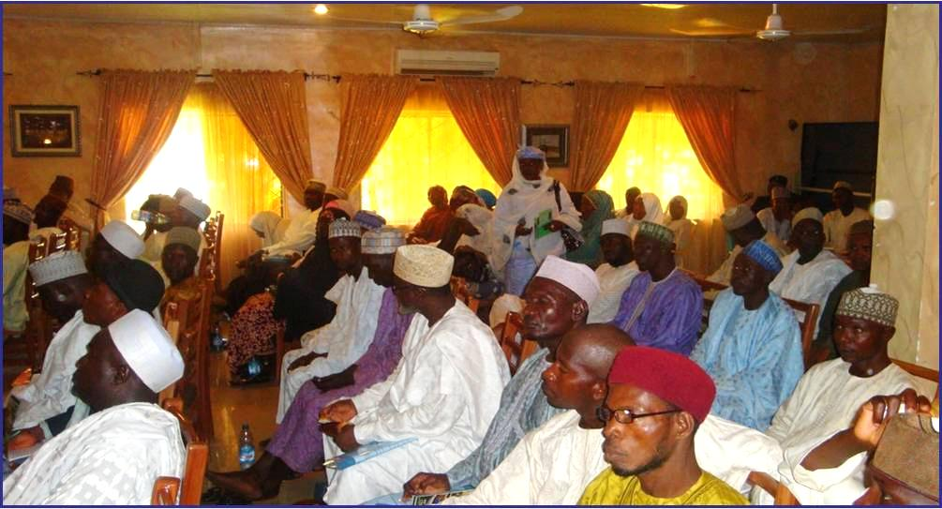
Civil Society and Media
Since 1998, USAID has made substantial investments in the development of Civil Society Organizations and media to promote good governance in Nigeria. As a result, democracy in Nigeria has advanced through substantial engagement of civil society in the constitutional and electoral processes; advancement of anti-corruption; and improvement in the rights of women and other marginalized groups. USAID civil society programs provide capacity building and support civic advocacy and media professionalism, focusing on membership organizations and larger civil society groups as targets for advocacy work, particularly on anti-corruption reforms. USAID’s programs also support advocacy campaigns; monitor democratic reforms aimed at strengthening transparency, accountability, and responsiveness of government institutions; strengthen public awareness; discourse and support for key democratic issues and inclusive good governance.
Independent National Electoral Commission consultative meeting with State Chairmen, women leaders and secretaries of political parties - Sokoto, 2011
CONTACT INFORMATIOn
Mission Director
Michael Harvey
Murjanatu House
No. 1 Zambezi Crescent
Off Aguiyi Ironsi Way
Maitama, Abuja, Nigeria
P.M.B. 519 Garki, Abuja
Tel: 234-09-461-9400

Desk Officers
Chad Weinberg
Tel: +1 202-712-0511
Email: cweinberg@usaid.gov
Julie Fitzgerald
Tel: +1 202-712-1422
Email: jfitzgerald@usaid.gov

Conflict Mitigation and Reconciliation
In conflict management and mitigation, USAID promotes stronger and broader collaboration between government and civil society to reduce sources of communal tension and violence in selected States and build robust conflict early-warning systems. USAID uses a community-based approach to draw on the expertise of religious and traditional leaders, women and youth groups, government officials, and civil society to develop systems, protocols, and reference materials to improve responses to outbreaks and threats of violence. USAID activities also support public information campaigns to promote peaceful resolution of conflicts, especially in targeted northern states.

