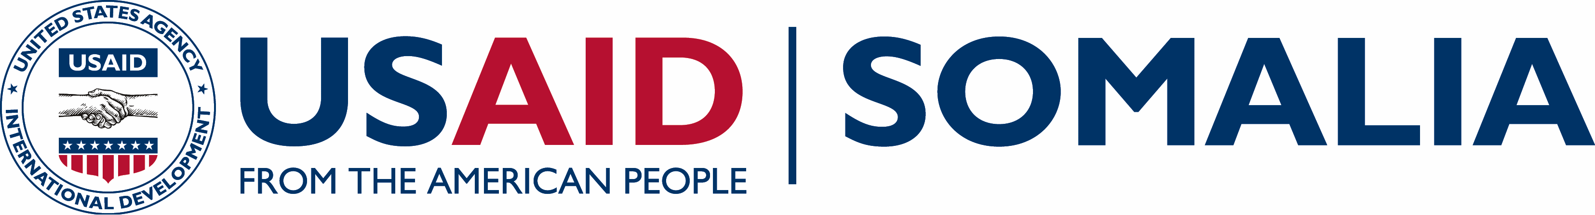
Growth, Enterprise, Employment and Livelihoods (GEEL)

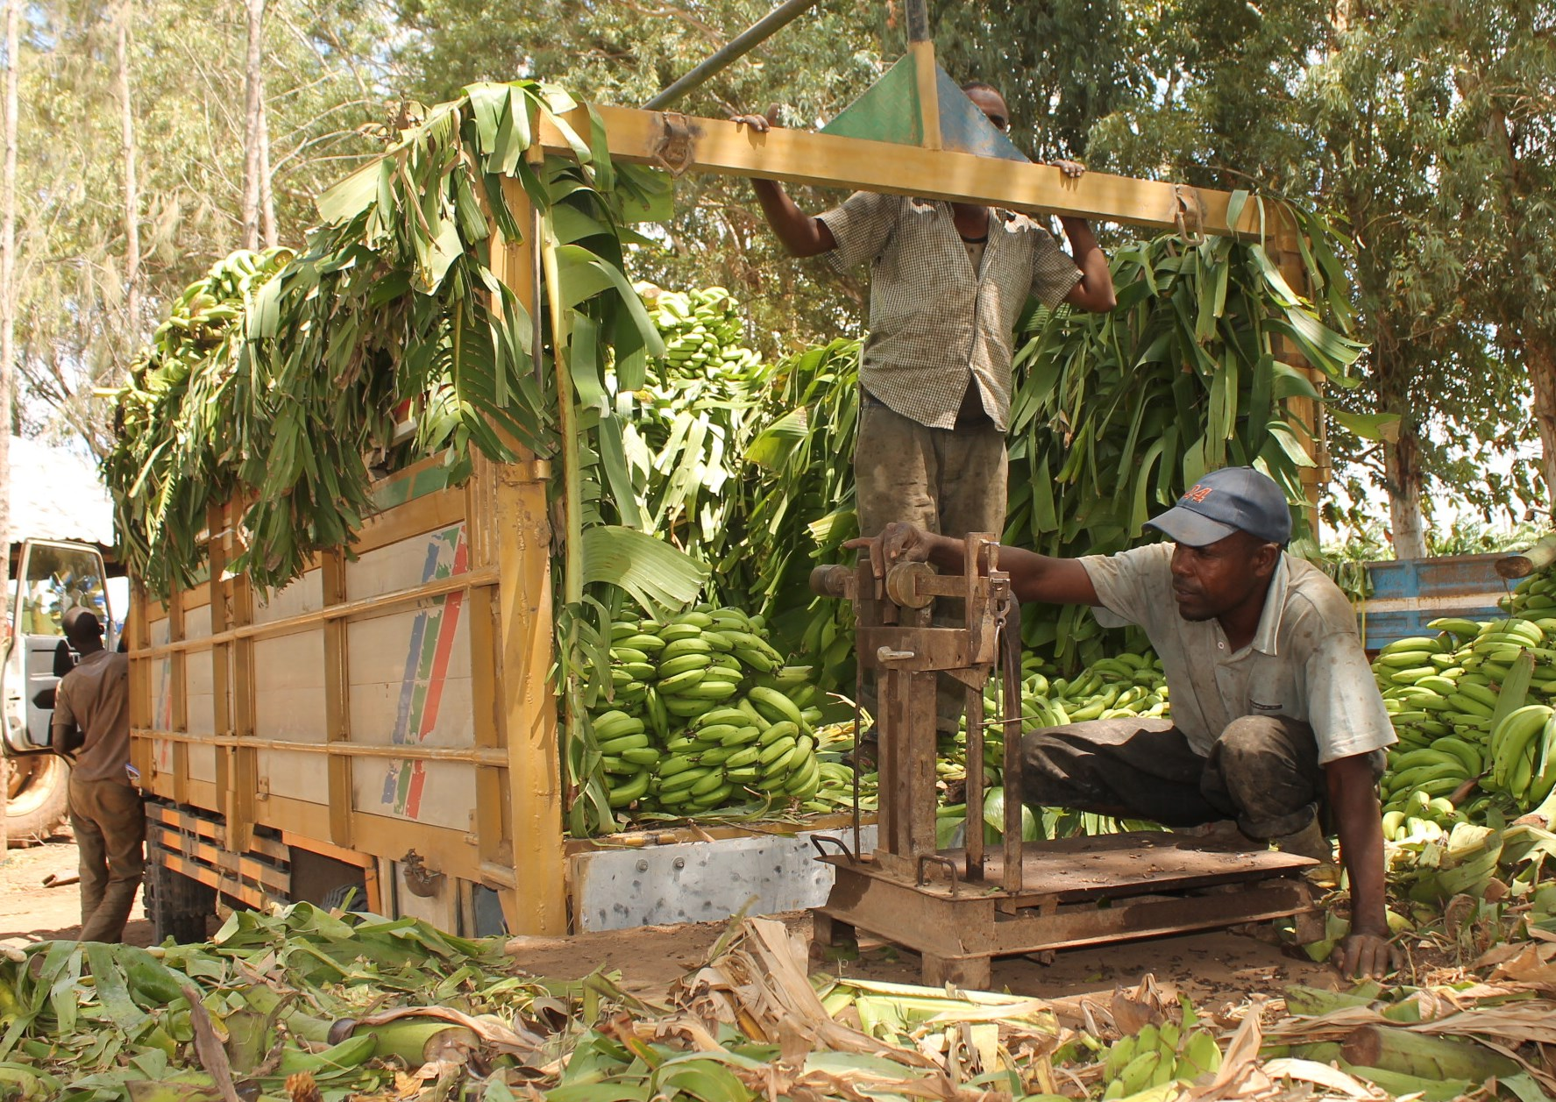  Mohamed Abdinoor USAID/GEEL  Banana farmers weighing in their profits  Funding Level:  $74.0 million (maximum ceiling)  Duration:  September 2015 – September 2020  Activity Goals:  - Improve the business environment through access to finance and support to policy and regulation  - Promote enterprise development through business development services  - Increase participation of women and youth in the economy as employers, employees and entrepreneurs  - Improve production, employment, and incomes in select sectors  Activity Accomplishments:  - $2.7m in sales generated at the Gulfood fair event in Dubai where 12 GEEL sponsored businesses exhibited agricultural products  - Almost 500 sesame farmers trained on efficient agricultural practices with courses at 30+ demo plots  - Over 1,000 enterprises received technical assistance to improve business management practices, enhance productivity and efficiency, and access to finance  - 360 jobs created over the last six months (Oct 2016 – March 2017)  - Five competitiveness events organized for the banana, sesame, dairy, and women in agribusiness and fisheries sectors  - Successful cooperation between the FGS and Kenyan Government in the prosecution and fining of an illegal fishing vessel in Somali waters  - 17 Somali government officials sponsored to participate in seven meetings and forums to promote learning of industry practices and policy making  Activity Locations:  Somalia countrywide  Implementing Partner:  RTI International  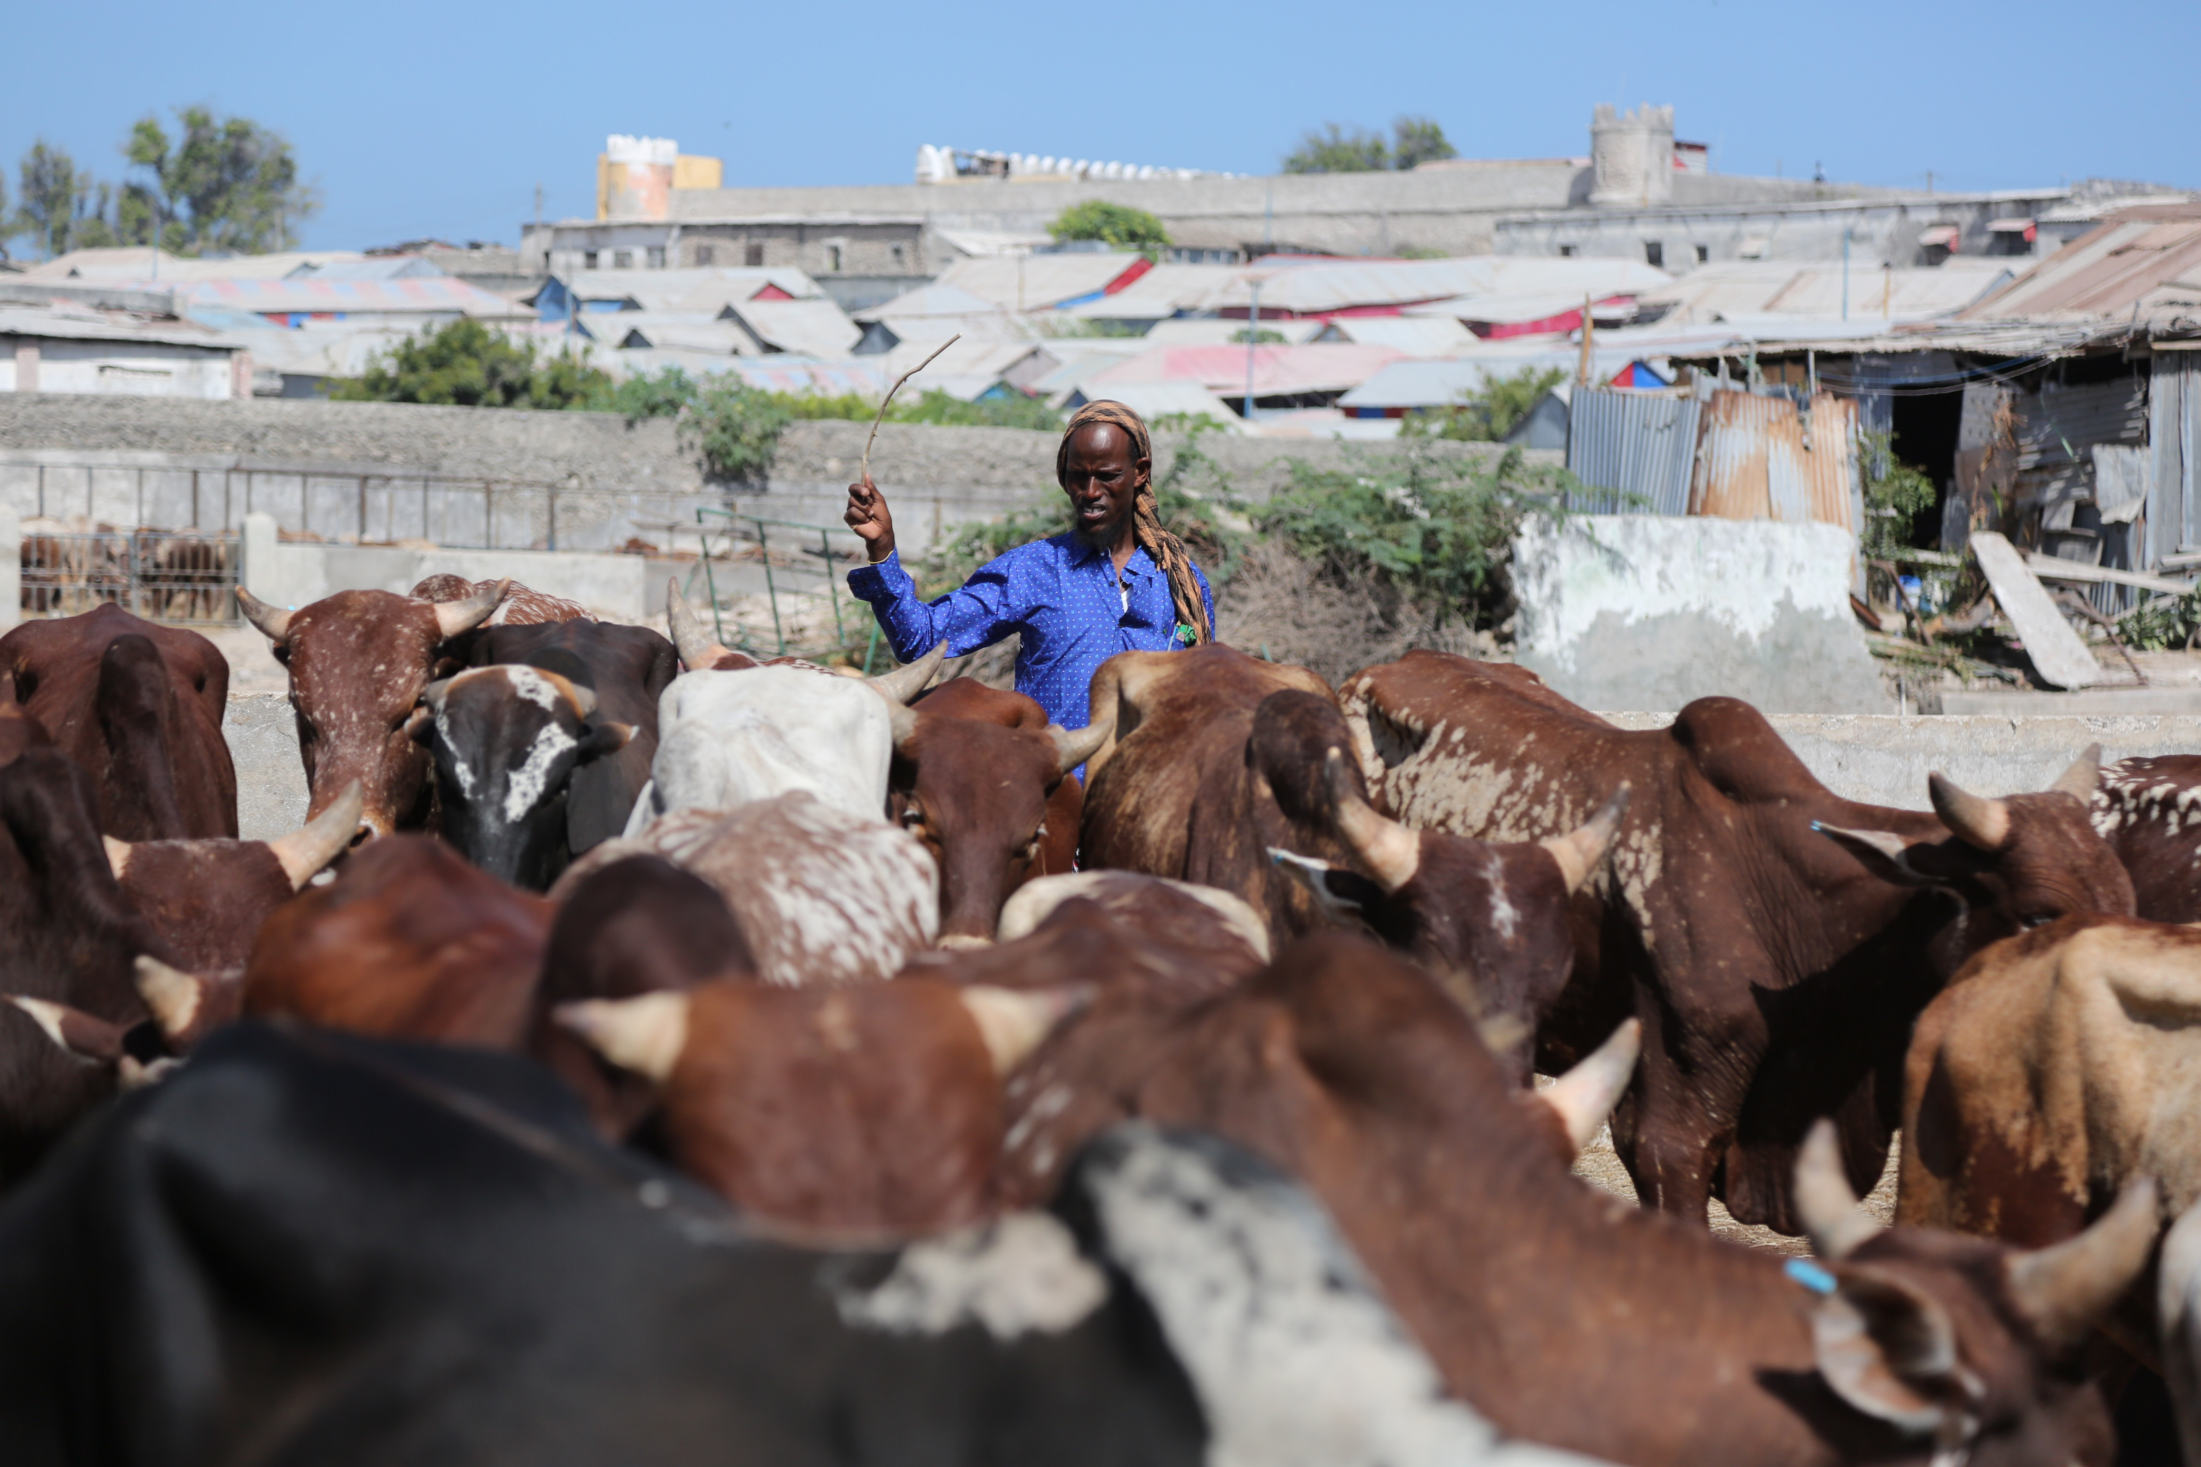  Key Partners  Shuraako  PIMS/DFID  Ministry of Fisheries & Marine Resources  Ministry of Agriculture and Ministry of Livestock, Range and Forestry  Banyan Global  SSG advisors  For more information contact:  usaidsomalia-info@usaid.gov  or info@sogeel.org | ACTIVITY OVERVIEW  The Growth, Enterprise, Employment and Livelihoods (GEEL) program promotes inclusive economic growth throughout Somalia. Through GEEL, USAID accelerates Somalia’s growing integration into the global economy through a combination of initiatives that improve the country’s competitiveness; spur new investments; and increase market linkages and business partnerships. This program aims to boost Somali exports of quality agriculture and fish, increase dairy production, reduce reliance on inputs, and increase jobs in regions recovering from years of conflict and recurrent natural disasters.  GEEL is leveraging the growing capacities of the government at the federal, regional, and local levels that build foundations for an enabled environment for economic growth. Activities are focused on sectors with high potential across all regions in Somalia and Somaliland.  ACTIVITY AREAS  GEEL activities are divided into two broad categories – those focused on priority economic sectors, and those addressing challenges and opportunities that are common among multiple sectors.  GEEL prioritizes activity sectors from within the broad areas of agriculture, fisheries, and dairies. It strengthens the start-up and expansion of small and medium-sized businesses, emphasizing women, youth and other disadvantaged groups as part of the economic development process. The program builds the capacity of internal investors as well as the Somali diaspora eager to invest in business opportunities.  A ‘competitiveness’ approach illuminates the common interests that Somalis have in working together in the sectors to succeed internationally, and identifies the specific actions that the private sector and government need to take for the country to become increasingly competitive. Priority interventions include attracting capital investment to create new businesses and expand existing businesses; introducing advanced technologies to improve efficiency; and increasing the ability of agribusinesses and fisheries enterprises to comply with internationally accepted food, health and hygiene regulations for the export market.  Addressing challenges and opportunities that span multiple sectors reduces barriers to economic growth and promotes competition in Somalia’s economy, especially start-up firms, SMEs and women and youth-owned businesses. GEEL encourages players in the private sector to collaborate in new ways with each other and with federal and other government counterparts to maximize the opportunities available. GEEL is working with food processors, investors in boat-building, refrigeration and transport services, financial institutions and university faculties, to name a few. Activities include introducing efficient irrigation systems, pioneering export crops, constructing small-scale infrastructure projects like irrigation canals, access roads and fish landing-piers, and training technicians on solar and wind power technology.  ACTIVITY IMPACT  Somalia plays a substantial role in the global sesame trade. GEEL trained 489 sesame farmers on efficient agricultural practices, sound infrastructure and market linkages. Trainings are continuous and are currenly conducted on 35 demonstration plots, directly transferring skills and knowledge to the farmers. Some of the sesame has already been harvested, providing income for farmers and insight to successful sesame production for the next season.  Somalia is going through a unique and progressive transformation with immense trade opportunities to be leveraged. Somali business is at a turning point in terms of global trade, and GEEL ensured that Somali companies secured a space at the Gulfood Trade Fair. They displayed sesame, pulses, fresh fruit, dried lemon, frankincense and meat from Somalia; connected with potential traders, investors and industry peers; and capitalized on new trade opportunities. As a result, new sales of $2.7m were generated with additional anticipated sales of $1.6m. Their presence announced Somalia’s re-emergence in the global food market and built a bridge for future development and investment.  Somali waters are home to some of the richest fishing grounds in Africa, but illegal fishing is robbing the country’s economy of a source of revenue that could help boost coastal social and economic development, improve export earnings and create thousands of jobs. To address this issue, GEEL supported the Ministry of Fisheries and Marine Resources to join the Fish-i-Africa network, a collaboration of eight East African States fighting Illegal, Unreported and Unregulated (IUU) fishing in the region. As a direct result of this, Somalia, in collaboration with Kenya authorities, were able to arrest and fine an illegal trawler that has now ceased IUU activity in Somali waters.  Worsening drought conditions across Somalia and Somaliland have affected the availability of food and water in the country. With GEEL’s support, dairy livestock enterprises are importing animal feed for over 11,000 animals and facilitating the destocking of drought stricken livestock, where herds are sold off before starvation, generating over $1.5m in revenue and counting. These intervensions ensure that a market is created at a time where many have collapsed, and pastoralists have access to income to carry them through the drought.

