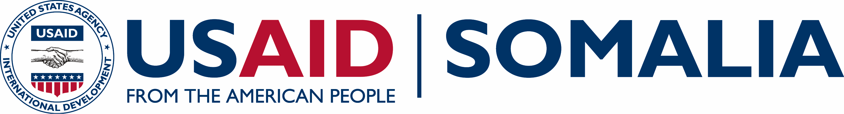

Bringing Unity, Integrity and Legitimacy to Democracy (BUILD)
USAID
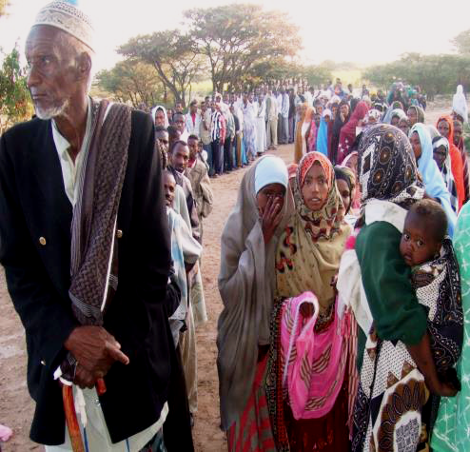  Citizens gathered outside a polling station in Somaliland.  Funding Level:  $24 million  Duration:  March 2016 – March 2021  Activity Goal:  - Increased participation and trust in political processes among citizens  - Increased engagement of electoral stakeholders, including EMBs, government agencies, political parties, and media, and greater integrity, accountability, transparency, and inclusivity in electoral processes throughout the electoral cycle  - More engaged CSOs on constitutional and legislative processes pertaining to elections  - More inclusivity of clans, women, youth, and other marginalized groups in the electoral process  Activity Accomplishments:  - Advised the National Independent Electoral Commission of Somalia on political party registration legal requirements and procedures  - Provided technical assistance to the Somaliland National Election Commission on budgeting and operational planning  - Procured and delivered to the Somaliland National Election Commission the equipment and supplies to print voter ID cards for all registered voters  - Supported a select committee of civil society representatives to draft an information source book on civic and voter education messaging for Somalia  Activity Locations:  Somalia countrywide  Implementing Partner:  Creative Associates International  Key Partners:  Electoral Institute for Sustainable Democracy in Africa (EISA)  Forcier Consulting  International Republican Institute (IRI)  For more information contact:  usaidsomalia-info@usaid.gov | OVERVIEW  While Somalia is moving towards more inclusive institutions and systems, most citizens have never participated in a direct election. In February 2016 Somalis successfully conducted an indirect electoral process where 14,000 delegates voted for MPs, and they in turn voted in a new president. The federal government of Somalia (FGS) has committed to one-person-one-vote elections in Somalia in 2020 and is in the process of reviewing its provisional constitution that may lead to a constitutional referendum to ratify the finalized document.  Somaliland has been conducting direct elections since 2002. The current cycle of elections have been delayed multiple times. The presidential election is now scheduled for November 2017, and parliamentary polls in April 2019.  Bringing Unity, Integrity and Legitimacy to Democracy (BUILD) aims to support electoral and political processes across Somalia, including Somaliland, by fostering increased citizen participation; building the capacity of election management bodies (EMBs) and other relevant government bodies to administer credible elections; and supporting the development of issue-based and viable political parties.  ACTIVITY AREAS  BUILD works with a range of Somali institutions and organizations to incrementally increase awareness of civic rights and responsibilities, while establishing and strengthening key political structures to facilitate and support citizen participation.  Specifically, BUILD: 1) Encourages citizen participation in political and electoral processes through building civil society organizations’ capacity to inform citizens and monitor elections and political processes; 2) Improves media capacity to cover and disseminate information on these processes; 3) Develops the capacity of Election Monitoring Bodies (EMBs) and other relevant government bodies to administer credible elections and political processes; and 4) Supports political parties to become more competitive, inclusive and representative of citizens’ interests.  BUILD issues small grants to local organizations in order to strengthen and expand existing civil society networks and support voter education and outreach to citizens on key political processes, including the constitutional review. It also provides technical advice to EMBs in order to organize elections; conducts political skills training programs for political parties; and also trains political party agents to observe elections.  ACTIVITY IMPACT  In Somalia BUILD will continue to lay the groundwork for supporting the planned 2020 one-person, one-vote elections by supporting the National Independent Election Commission (NIEC) to fulfill their mandate. BUILD facilitated sessions on relations between electoral management bodies and political parties to support the development of policies necessary for registration and the implementation of the 2016 Political Parties Act. BUILD is also supporting the NIEC on strategic planning, operational management and knowledge management.  BUILD is supporting civil society organizations in Somalia to develop civic and voter education messaging that will be used in outreach related to constitutional review, voter registration and other key political processes.  In Somaliland, BUILD supported the National Elections Commission (NEC) in revising its budget. This assistance built the foundation for discussions with government and donors on election financing. BUILD also focused on supporting Somaliland’s presidential election, in particular by providing technical assistance, equipment and supplies for the printing of voter ID cards. ID cards for all registered voters have now been printed and will be distributed in advance of the presidential election.

