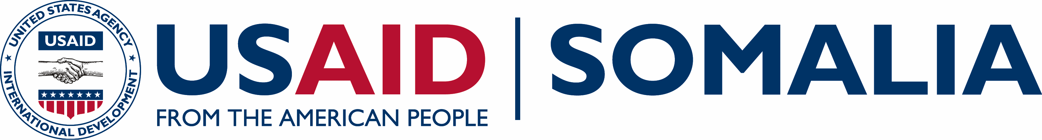
Strengthening Somali Governance (SSG)
USAID
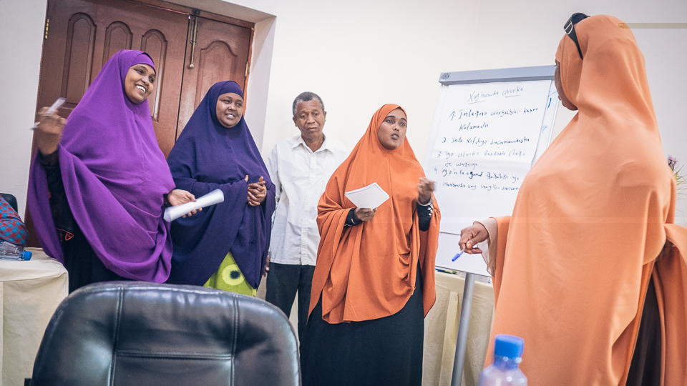  Participants attending a human resources workshop on Designing Performance Evaluations engage in a role-playing exercise.  Funding Level:  $25.3 million  Duration:  September 2014 – September 2018  Activity Goals:  - Improve the legislative, representative, and oversight functions of Somalia and Somaliland’s legislatures.  - Improve the ability of targeted government institutions to perform essential functions  - Increase citizen awareness of and engagement in government decision-making  Activity Accomplishments:  - The Media, Foreign Investment Bill, Procurement Bill, Anti-Money Laundering Bill passed by the Federal Parliament with SSG’s assistance in their preparation and drafting  - 3238 training days provided to civil servants in key subject areas such as accounting, public financial management, office administration, and communications  - Over 115 journalists trained on governance and conflict sensitive reporting  - 10,275 individuals received voter and civic education in anticipation of the Somaliland elections in Nov. 2017  Implementing Partner:  Chemonics  Activity Locations:  Somalia countrywide  Key Partners:  Ministry of Planning and International Cooperation (MoPIC)  Ministry of Finance  Inter-Governmental Authority on Development (IGAD)  Ministry of Women’s Affairs and Human Rights (MoWHR)  Ministry of Planning and National Development (MoPND))  National Disability Council and Disability Coalition  For more information contact:  usaidsomalia-info@usaid.gov | ACTIVITY OVERVIEW  USAID’s Strengthening Somali Governance (SSG) supports the Federal Government and the Somaliland Government to support the development of effective and accountable governance institutions. SSG supports efforts to enhance government outreach, increase citizen participation, improve the functional capacity of key government institutions, and expand women’s empowerment and leadership.  ACTIVITY AREAS  SSG works collaboratively with parliaments, key ministries and commissions, and civil society to improve core management functions, such as financial management, human resources, planning processes, and public communications and outreach to support the creation of strong and credible democratic institutions in Somalia.  SSG improves the capabilities of parliamentarians and government officials to deliberate on, amend, draft, analyze and enact key pieces of legislation, and improves the administrative capabilities of government staff and/or civil servants to develop policies, effectively coordinate government systems, and efficiently manage daily operations.  Throughout the project, SSG is engaging civil society and the media to increase citizen awareness of key political processes, such as the 2016-2017 political transition process and key legislation, government structures and activities, and the roles and responsibilities of executive and legislative officials to ensure greater transparency and engagement.  ACTIVITY IMPACT  SSG supported nine draft laws advancing representative governance that were subject to substantive amendment and final vote in the legislature. Four of these laws were passed by the Federal Parliament (Media, Foreign Investment, Public Procurement, and Anti-Money Laundering).  One-hundred thirty four events designed to build support for peace among key actors were held with USG assistance, and in total 12,256 people participated in USG-supported events to build support for peace. Over 10,000 individuals received either voter or civic education, which excludes those who were reached through media public service announcements, radio and television talk shows.  SSG provided skills development to Parliament in legislative drafting and regulatory reform, as well as asset management policy and office administration. Priority legislation was used as an opportunity to introduce norms for staff research and analysis, information gathering, discussion and debate, legislative amendment, and committee reporting. Five committees were trained on the process and procedures for public hearings.  SSG also supported the Federal Parliamentary Budget and Finance Committee to review and finalize the first public financial management bill in Somalia since 1961. In July 2017, SSG facilitated the first-ever public hearing on the FY2017 national budget with the HoP Budget and Finance Committee. The hearing was attended by civil society organizations (CSOs) representing the fields of education, health, women and youth, and persons with disabilities. Also in attendance were financial experts, committee members, media, and observers. The public budget hearing was broadcasted live on SNTV, Universal TV, and various social media sites, allowing the public to watch this historic event. The bill will be voted on in the new parliamentary session and, if enacted, will bring Somalia in line with international standards.  In Somaliland, the Parliament was supported to hold public hearings on five key public financial management and revenue bills, as well as the consolidated financial statements - the first time financial governance legislation and financial statements have ever been presented for public comment. USAID provided technical assistance to the Federal Ministry of Finance to conduct an assessment of the non-tax revenue being collected by line ministries, and to review existing payment systems. This resulted in greater transparency about the types of fees ministries are collecting and the methods used to do so.  To improve the capacity of the executive branch and ministries to communicate with each other and the public, SSG supported six ministries to implement their communications strategies, including the development of websites, training staff on the use of social media, and how to populate and maintain newly developed websites.  SSG also supported the “demand side” of government transparency and accountability by helping citizens understand the workings of government and how to advocate on behalf of their communities. USAID advanced civil society organizations’ understanding of advocacy methods, communication strategies, and coalition building focused on specific issues such as the 30% quota for women parliamentarians and disability rights. Five targeted media outlets are supported to help owners, editors, and journalists better understand governance issues and processes and improve the quality of their coverage.

