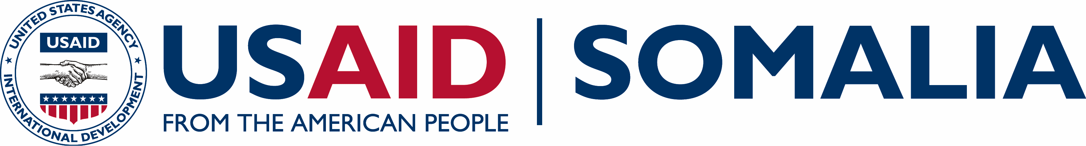  Somalia Overview  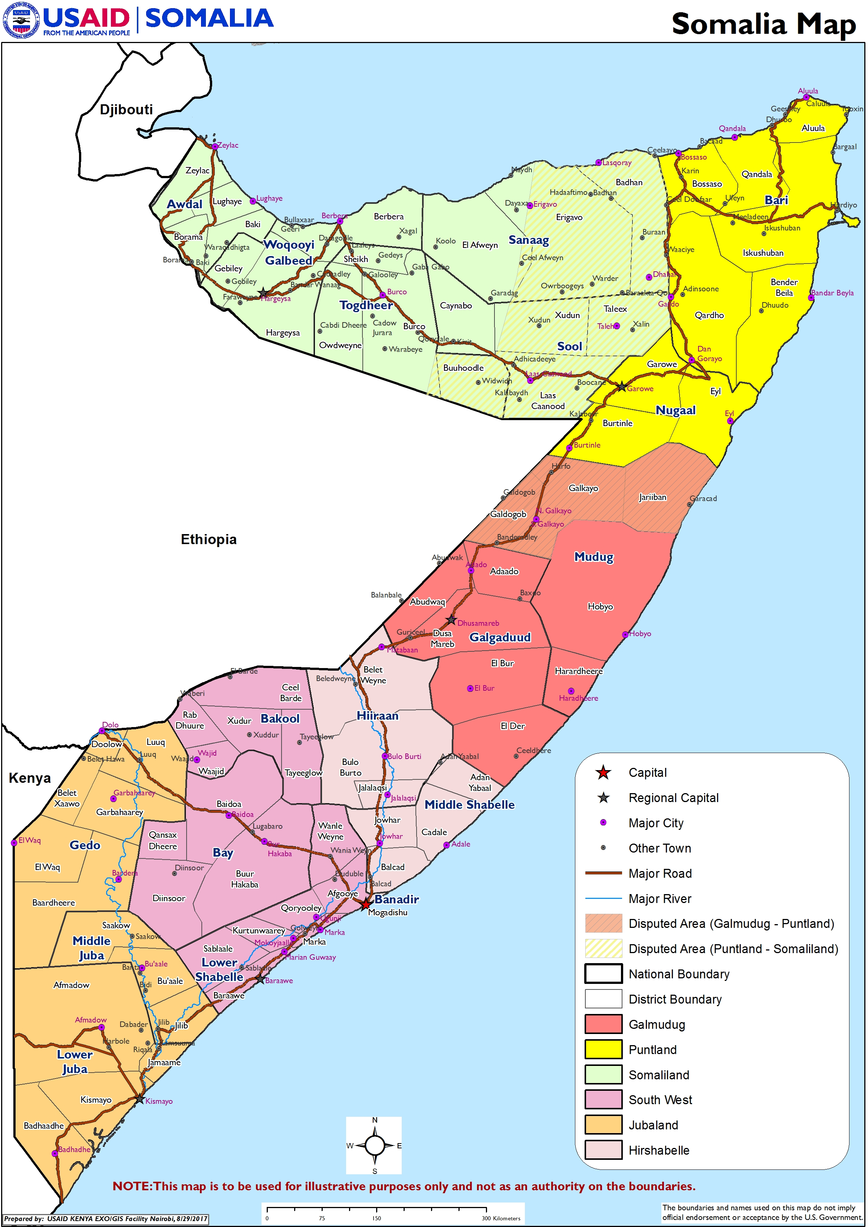  SOMALIA FACTS AND FIGURES:  13.8% of national parliamentarians are women. (World Bank)  98% of girls and women aged 15-49 have undergone female genital mutilation/cutting. (UNICEF)  29% of the total population has access to clean water. (UNICEF)  39% of the total population has access to sanitation. (UNICEF)  73% of the overall population is under 30 years of age. (UNDP)  8.2% and 11.5% of females and males, respectively, attended secondary school from 2008-2012. (UNICEF)  67% of youth aged 14-29 are unemployed. (UNDP)  USAID Funds  Fiscal Year 2017  Development and Stabilization: $47.3 million  Office of U.S. Foreign Disaster Assistance: $81.6 million  Office of Food for Peace Assistance: $220 million  TOTAL: $348.7 million  Development and Stabilization Funds  Obligated in FY 2017  USAID Contacts:  USAID/East Africa, Somalia Field Office  PO Box 629, Village Market 00621  Nairobi, Kenya  Phone +254 20 862 2000  Fax +254 20 862 2680  Monica Moore, Foreign Service Officer  USAID East Africa/Somalia  1300 Pennsylvania Avenue, NW  Washington, DC 20523  Tel: +1 202 216-3276  Email: momoore@usaid.gov  For more information:  Web site: usaid.gov/somalia  Email: usaidsomalia-info@usaid.gov  Twitter: @USAIDSomalia | OUR WORK  USAID seeks to strengthen the foundations for a more stable, democratic, and prosperous Somalia, while saving lives, alleviating human suffering, and reducing the economic impact of disasters.  Humanitarian Assistance  Office of Food for Peace (FFP)  Funding provided in FY 2017: $220 million  FFP provides emergency food and nutrition assistance through in-kind and market-based interventions to reduce acute food insecurity among the most vulnerable populations.  Office of U.S. Foreign Disaster Assistance (OFDA)  Funding provided in FY 2017: $81.6 million  OFDA supports humanitarian interventions to address acute emergency needs of vulnerable populations, including supporting early recovery and disaster risk reduction activities designed to protect and restore livelihood assets. OFDA provides assistance to humanitarian partners working in health, nutrition, water, sanitation and hygiene, agriculture, food security, protection, economic recovery and market systems.  Democracy, Stabilization and Governance  Transition Initiatives for Stabilization (TIS+)  Total Estimated Cost: $67 million  Start-End date: May 2015 – May 2020  TIS+ increases confidence in all levels of government through targeted, strategic interventions that improve service delivery and government responsiveness. Through TIS+ Somali government institutions, the private sector and civil society collaborate to design, evaluate and deliver projects with a quick and lasting impact on the lives of Somalis.  Somalia Stabilization Initiative (SSI)  Total Estimated Cost: $25 million  Start-end date: February 2016 – February 2019  SSI provides assistance to communities previously under al-Shabaab control, and connects communities to state and local governments with an initial focus on Jubaland and the South West States of Somalia.  Somalis Harmonizing Inter-and-Intra Communal Relationships (SHIIR)  Harnessing Opportunities for Peaceful Engagement (HOPE)  Total Estimated Cost: $2.4 million  Start-end date: October 2016 – September 2018  SHIIR works in Jubaland on social reconciliation activities that will enable community cohesion and identify how to collectively advocate for inclusive state building processes. HOPE aims to increase community resilience to violence in Afgoye district by strengthening community relations and decision-making at the local level.  Strengthening Somali Governance (SSG)  Total Estimated Cost: $25.3 million  Start-End date: September 2014 – September 2018  SSG supports the development of effective and accountable governance across Somalia. With a focus on delivering credible political processes envisioned under the Federal Government of Somalia’s Vision 2016 roadmap, SSG supports efforts to enhance government outreach; increase citizen participation; improve the functional capacity of key government institutions; and expand women’s empowerment and leadership.  Bringing Unity, Integrity, and Legitimacy to Democracy (BUILD)  Total Estimated Cost: $28.9 million  Start-End date: March 2016 – March 2021  BUILD supports electoral and political processes in Somalia and Somaliland by fostering increased citizen participation; building the capacity of election management bodies and other relevant government bodies to administer credible elections; and supporting the development of issue-based and viable political parties who promote inclusion and contribute to peaceful political processes.  Education & Youth Engagement  Alternative Basic Education for Pastoralists (ABE)  Total Estimated Cost: $10 million  Start-End date: September 2015 – September 2020  ABE is expanding the provision of education services by improving access to equitable, quality education for pastoralists and other marginalized children in Jubaland State of Somalia. Programs target children and youth disconnected from school for significant periods of time or who have never been to school.  Health  Increasing Access to Quality Maternal and Child Health Services in Somalia, Puntland and Somaliland through the Private and Public Sector  Total cost: 1.5 million  Start-End date: October 2017 – September 2018  USAID through Population Services International Somaliland (PSI) aims to increase access and coverage of maternal and child health services; increase informed demand of health services in both the private and public sector; and support operationalization of the Health Sector Strategic Plans (HSSPII) for the Federal Government of Somalia.  Economic Growth  Growth, Enterprise, Employment and Livelihoods (GEEL)  Total Estimated Cost: $74 million  Start-End date: September 2015 – September 2020  GEEL is designed to promote inclusive economic growth throughout Somalia, Somaliland and Puntland through activities that address challenges and opportunities that are common among multiple sectors and initiatives that affect key industries, particularly agriculture, fisheries, and renewable energy. The program builds the capacity of internal investors as well as the Somali diaspora eager to invest in business opportunities, and prioritizes opportunities in industries likely to attract women and youth who have been marginalized from pursuing economic opportunities.  Resilience  STORRE, PROGRESS and REAL  Total Estimated Cost: $14 million  Start-End date: September 2014 – September 2017  USAID has three multi-sectoral programs designed to increase the capacity of households and communities to adapt to recurrent shocks; build on the ecological, social and economic capital of households and communities; and promote learning for members of targeted communities, as well as the broader community of resilience stakeholders.  Monitoring and Evaluation  Somalia Program Support Services (SPSS)  Total Estimated Cost: $24 million  Start-End date: August 2014 – July 2019  SPSS provides monitoring and verification services; evaluations and assessments; and provides performance management and learning support for program effectiveness.  Somali Engineering and Architectural Support (SEAS)  Total Estimated Cost: $874,000  Start-End date: September 2014 – September 2019  SEAS reviews engineering designs, monitors construction, and verifies environmental compliance of USAID-funded rehabilitation and small-scale infrastructure activities.  Multi-Donor Trust Fund Contributions  International Monetary Fund - Somalia Trust Fund (STF)  Total Contribution: $1 million  Start-End date: May 2016 - January 2018  The STF aims to improve macro-economic institutions, policies and data systems, and supports the Central Bank of Somalia and the Ministry of Finance.  World Bank Multi-Partner Fund (MPF)  Total Contribution: $3 million  Start-End date: September 2016 – September 2019  The MPF contributes to 13 programs in economic and financial governance.

