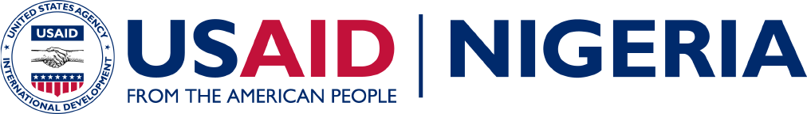

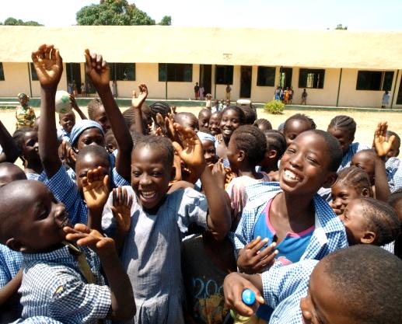
Nigeria’s education system has not kept pace with the rapid population growth and growing school-age population. The quality of basic education in Nigeria is extremely poor, leading to low demand and unacceptably low academic performance. There are 30 million primary school-aged children in the country, of whom an estimated 10 million are not enrolled in school. Of those students currently in primary school, less than one third will attend junior secondary school and even fewer will proceed to senior secondary school. Nigeria has a massive number of out-of-school children and youth with limited literacy and numeracy skills who have little hope of ever joining the formal workforce. While education indicators are poor nationwide, the greatest need for assistance is in the predominantly Muslim north.
Budget 2012-2014:
2012: $ 22 million
2013: $ 31 million
2014 (est.): $ 16 million
Students celebrate school renovation Aricha Local Authority Primary School - Akwanga, Nassarawa State, 2008
USAID programs support equitable access to quality basic education through teacher training; support for girls’ learning; community involvement, and reading and literacy skills development. The programs target public schools, as well as integrated Islamiyyah and Quranic schools, which provide both secular and religious education.
results:
- Strengthened key education management systems in target states
- Strengthened delivery of teacher training services for primary schools
- Improved capacity to deliver education services to at-risk populations
- Improved student reading skills
- Strengthened policy decisions based on strategic information at state and local levels
- Increased access to out of school children

Basic Education
Working in two Northern States, Bauchi and Sokoto, USAID employs a system strengthening approach that supports these State governments to deliver basic education services by addressing key issues in the management, sustainability and oversight of basic education. The Initiative also strengthens non-formal education systems to provide orphans and vulnerable children with reading, mathematics and life skills; psycho-social counseling; and access to health care referrals. It is expected to increase access to basic education and services such as health information and counseling for orphans and vulnerable children in focal northern states. Two hundred public schools in Bauchi and Sokoto States are benefiting from this initiative. A major achievement has been the adoption of a new system that tracks and prioritizes funding for education. This approach has led to an increase in the education budget of the two states.
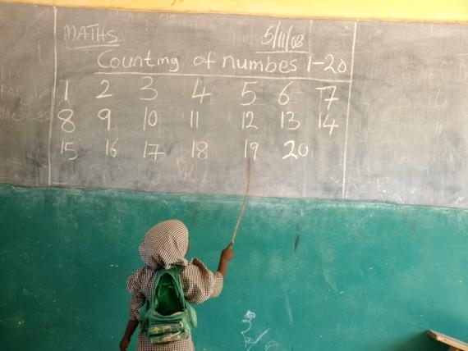
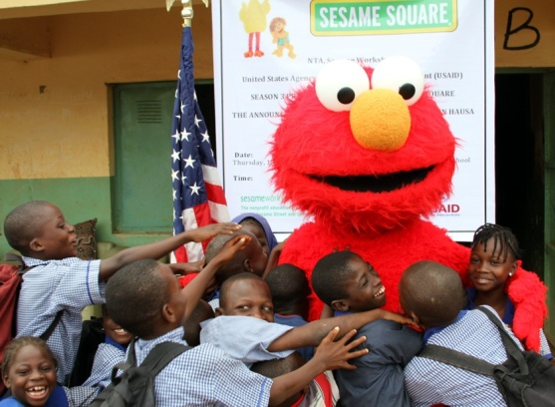
In addition to system strengthening, USAID mobilizes Nigeria’s major mass media outlets, primarily local television and print media, to provide consistent and daily access to innovative educational programming designed to enhance school readiness for low-income, under-resourced young children.

USAID supports girls’ education - Kano, 2009
Elmo and Pupils of Ushafa LEA School after the Launch of Sesame Square Season 3 - Bwari Local Council, FCT 2013

CONTACT INFORMATIOn
Mission Director
Michael Harvey
Murjanatu House
No. 1 Zambezi Crescent
Off Aguiyi Ironsi Way
Maitama, Abuja, Nigeria
P.M.B. 519 Garki, Abuja
Tel: 234-09-461-9400

Desk Officers
Chad Weinberg
Tel: +1 202-712-0511
Email: cweinberg@usaid.gov
Julie Fitzgerald
Tel: +1 202-712-1422
Email: jfitzgerald@usaid.gov

